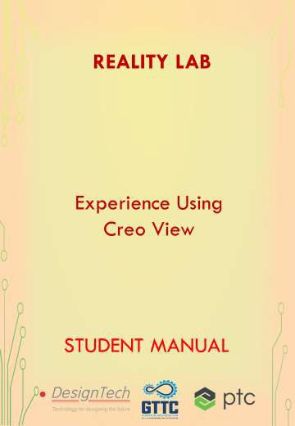

**REALITY LAB**

* Augmented Reality unlocks the value created by the **CONVERGENCE** of the

**PHYSICAL** and **DIGITAL** worlds.

* Implementing AR technology, industrial enterprises are boosting workforce efficiency and safety, improving operational performance, and lowering costs across the factory and the field.
* **Hardware Equipped:**

|  |  |  |
| --- | --- | --- |
| **Sr. No.** | **Name of hardware** | **Qty.** |
| 1. | Wireless Glasses Kit - NVIDIA 3D Vision® 2 | **5** |
| 2. | 3D LED Projector - BENQ | **1** |

* **Software’s Equipped:**

|  |  |  |
| --- | --- | --- |
| **Sr. No.** | **Name of Software** | **Qty.** |
| 1. | Creo Essentials | **5** |
| 2. | Creo Direct | **5** |
| 3. | Creo Interactive Surface Design Extension | **5** |
| 4. | Creo Advanced Rendering Extension | **5** |
| 5. | Creo Mechanism Design Extension (MDX) | **5** |
| 6. | Creo Mechanism Dynamics Extension (MDO) | **5** |
| 7. | Creo Piping Design Extension | **5** |
| 8. | Creo Advanced Rendering Extension | **5** |
| 9. | Creo View Design Check | **5** |
| 10. | Creo Model CHECK Extension | **5** |
| 11. | Creo View ECAD - Registered User License | **5** |
| 12. | Creo Advanced Framework Extension (AFX) | **5** |
| 13. | Creo Options Modeler Standard Application | **5** |
| 14. | Creo Industrial Designer | **5** |
| 15. | Creo Plastic Advisor Extension | **5** |
| 16. | Creo Progressive Die Extension (PDX) | **5** |
| 17. | Creo NC Sheet metal Extension | **5** |
| 18. | Creo Computer Aided Verification Extension | **5** |
| 19. | Pro/INTRALINK | **5** |
| 20. | WC Quality Solution Education Seat | **5** |
| 21. | WC Quality solution e-learning Library | **5** |
| 22. | Windchill Server Access | **5** |
| 23. | Windchill Partslink Classification & Resuse | **5** |
| 24. | Windchill PDM Link Heavy | **5** |
| 25. | Windchill Project Link Heavy | **5** |

* **COURSES OFFERED:**

|  |  |  |
| --- | --- | --- |
| **S. No** | **Name of the Course** | **Duration** |
| 1 | Experience Using Creo View | 40 Hours |

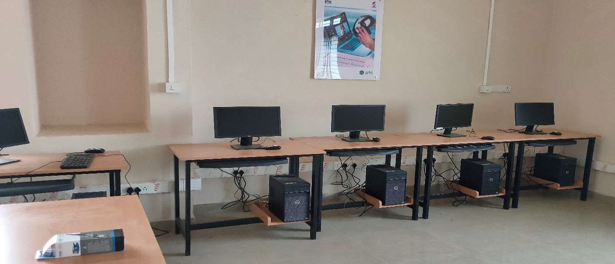

**AUGMENTED REALITY EXPERIENCE USING CREO VIEW**

Augmented Reality (AR) is the overlay of digital content into the real world. Digital content comprises of 2-D text, graphics, 3-D models, GPS data, Web information, animation sequences, and so on.

**Examples of AR:**

1. Pokémon Go Game
2. Harry Potter Wizards
3. Snapchat

**Capabilities of AR**

1. **Visualize** – Visualize option includes visualizing 2-D information and 3-D models.
2. **Guide** – The second capability is used to guide and instruct.
3. **Interact** – The third capability is to interact.

**COURSE OFFERED:-**

|  |  |  |
| --- | --- | --- |
| **S. No** | **Name of the Course** | **Duration** |
| 1 | Experience Using Creo View | 40 Hours |

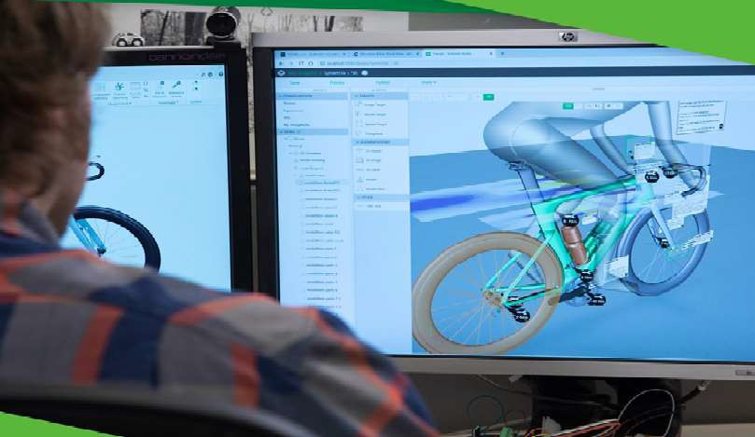

**INDEX**

|  |  |  |
| --- | --- | --- |
| CHAPTER 1 | Course Overview | 01 – 09 |
| CHAPTER 2 | Customization | 10 – 22 |
| CHAPTER 3 | Import, Export and Save Files | 23 – 25 |
| CHAPTER 4 | Annotations | 26 – 33 |
| CHAPTER 5 | Sequences | 34 – 40 |
| CHAPTER 6 | Reports and File Formats | 41 – 46 |
| CHAPTER 7 | Construction Geometry | 47 – 52 |
| CHAPTER 8 | Augmented Reality | 53 – 56 |

**TABLE OF CONTENTS**

|  |  |
| --- | --- |
| **CHAPTER 1 - COURSE OVERVIEW** | **01 – 09** |
| Course Overview | 01 |
| To Set the Edition and License Options | 02 |
| User interface | 02 |
| Viewing | 02 |
| Navigating the structure | 03 |
| Performing commands | 03 |
| Configuring | 03 |
| Getting information | 03 |
| Ribbon | 03 |
| Tab | 04 |
| Button | 04 |
| Gallery | 06 |
| To customize the ribbon | 06 |
| To customize the ribbon using the options dialog box | 06 |
| To hide a tab or a group | 06 |
| To rename tab or a group | 07 |
| To add an existing group or a button | 07 |
| To remove a group or a button | 07 |
| To define a new cascade | 07 |
| To modify the button style | 08 |
| To modify the image or cascade | 08 |
| To move the buttons to or from the overflow | 08 |
| To export and import custom user interface settings | 08 |
| To restore the default interface settings | 09 |
| To customize commands using the options dialog box | 09 |
| **CHAPTER 2 – CUSTOMIZATION** | **10 – 22** |
| To add a command to the quick access toolbar | 11 |
| To remove a command from the quick access toolbar | 12 |
| About customizing the palettes | 14 |
| To add colors to the palettes | 15 |
| To edit or delete custom colors | 16 |

|  |  |
| --- | --- |
| About Creo view formats | 16 |
| About opening structures and designs | 16 |
| About opening files with copyrights | 18 |
| About adding or deleting viewable | 19 |
| About working with parts or bodies | 21 |
| **CHAPTER 3 - IMPORT, EXPORT AND SAVE FILES** | **23 – 25** |
| About importing and exporting files | 23 |
| Saving Files | 23 |
| Supported File types | 24 |
| **CHAPTER 4 – ANNOTATIONS** | **26 – 33** |
| About Annotation Sets | 26 |
| To open an annotation sets | 27 |
| To create an annotation | 29 |
| To hide or show an annotation | 31 |
| To edit an annotation | 32 |
| To edit a single annotation | 32 |
| To edit multiple annotation | 32 |
| To delete an annotation | 33 |
| **CHAPTER 5 – SEQUENCES** | **34 – 40** |
| About Sequences | 34 |
| To set the default materials | 37 |
| To import a list of materials | 38 |
| To export a list of materials | 38 |
| About a bill of materials | 38 |
| About an MCAD bill of materials | 39 |
| To set bill of materials options | 40 |

CHAPTER 6 - REPORTS AND FILE FORMATS 41 – 46

About a design data report 41

About saving Files 41

To save an external file format in Creo view 45

To generate a design data report 46

|  |  |
| --- | --- |
| **CHAPTER 7 - CONSTRUCTION GEOMETRY** | **47 – 52** |
| To create a construction geometry | 49 |
| To create a coordinate system | 49 |
| To load a construction geometry | 50 |
| To save construction geometry | 51 |
| Construction geometry references | 51 |
| **CHAPTER 8 - AUGMENTED REALIT** | **53 – 56** |
| About creating an Augmented Reality experience in Creo view | 53 |
| Creating an augmented reality experience for a CAD model | 54 |
| To publish an augmented reality experience in CAD model | 55 |

**CREO VIEW OVERVIEW**

**CHAPTER 1**



Creo view enables you to interrogate with ECAD designs and 3D MCAD products and models, assemblies, drawings, images and documents.

**You can perform the following tasks:**

**View structure**

Edit the appearance of a structure by changing part colour, render mode, location and orientation. Mark up a structure with annotations, measurements and construction geometry.

Group parts

**Create cross sections**

Move parts and change their appearance, such as creating exploded views and cross-sections With Creo team members can view, mark-up, interact, and collaborate all forms of digital product data, and visual information is shared across the enterprise.

Creo View comes in two licensed editions and one unlicensed edition:

* Creo View — includes all functionality, is either MCAD or ECAD based, and some applications require additional licenses.
* Creo View Lite — Provides limited viewing and markup functionality and interoperability with Windchill.
* Creo View Express — Provides basic viewing functionality without a license.

The Creo View license is configured for MCAD or ECAD or both. The Lite edition of the other configuration is provided.

Depending on the Creo View license configurations set up by the systems administrator, you can retrieve licenses for your workstation according to your tasks and borrow licenses for

working offline. The optional applications can be set to load at startup or when required. This flexibility enables efficient license sharing and smaller loads on workstations. To work offline, you must borrow temporary Creo View license.

**To Set the Edition and License Options**

* 1. Click **File** > **Options**. The Creo View Options dialog box opens.
  2. Next to Showing, select **Global**.
  3. On the left, under General, select Startup. The options open on the right.
  4. To change the language of the user interface, choose a language that is installed on your system.
  5. To select the edition and license options for each new session, select the check box.
  6. To determine the edition at the next startup, select one of these options next to Choose Creo View edition:
     + Creo View Lite
     + Creo View MCAD
     + Creo View ECAD
     + Creo View MCAD and ECAD
     + Creo View Standard The dialog box updates.
  7. For each license option you have, always load the license, load as needed, or never load:
* Load at startup
* Load when required
* Never
  1. To update your license, under License Information, type the license information in one of these boxes:
* License Server
* Pre-configured License Servers
  1. Click **Apply** to apply the options. Click OK to apply the options and close the dialog box.
  2. Restart Creo View to open with the new settings.

**User interface Viewing**

**Graphics area** — shows a visualization of the file. You can change the view to display 3D models, 2D drawings, images, and documents. Use the commands on the shortcut menus to control the view and to set viewing options. Several views (drawings, images and documents) can be open at the same time. Click a view to toggle between the open views.

**Navigating the structure**

* Primary panel
* Upper data panel

The panels show information about the product structure. You can click the arrow along the panel's sides or drag the edges of the panel to show or hide or to resize it. You can also access a panel command in the status bar in the bottom right corner of the window.

**Performing commands**

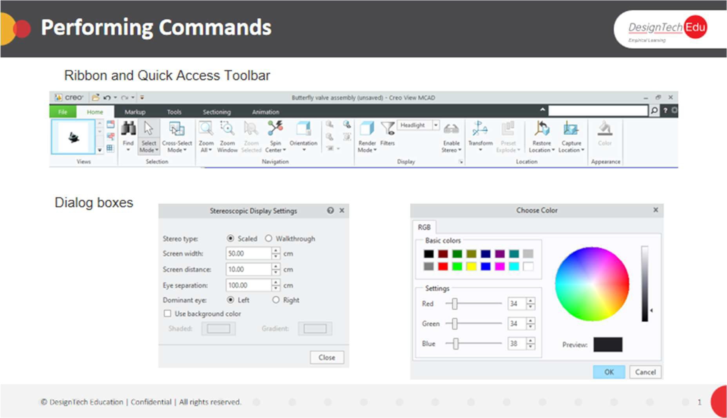

* Ribbon
* Quick Access Toolbar
* Dialog boxes

**Configuring**

Creo View Options

**Getting information**

* Lower data panel—Shows information such as attributes, messages, BOM, animation timeline, or interference results.
* Status bar—shows the name of the current view, selection method, unit settings, and show/hide buttons for the panels and the graphics area.

**Ribbon**

The ribbon contains command buttons organized in a set of tabs. On each tab, the related buttons are grouped. You can minimize the ribbon to make more space available on your screen. You can customize the ribbon by adding, removing, or moving buttons. The following figure shows the different elements of a ribbon.

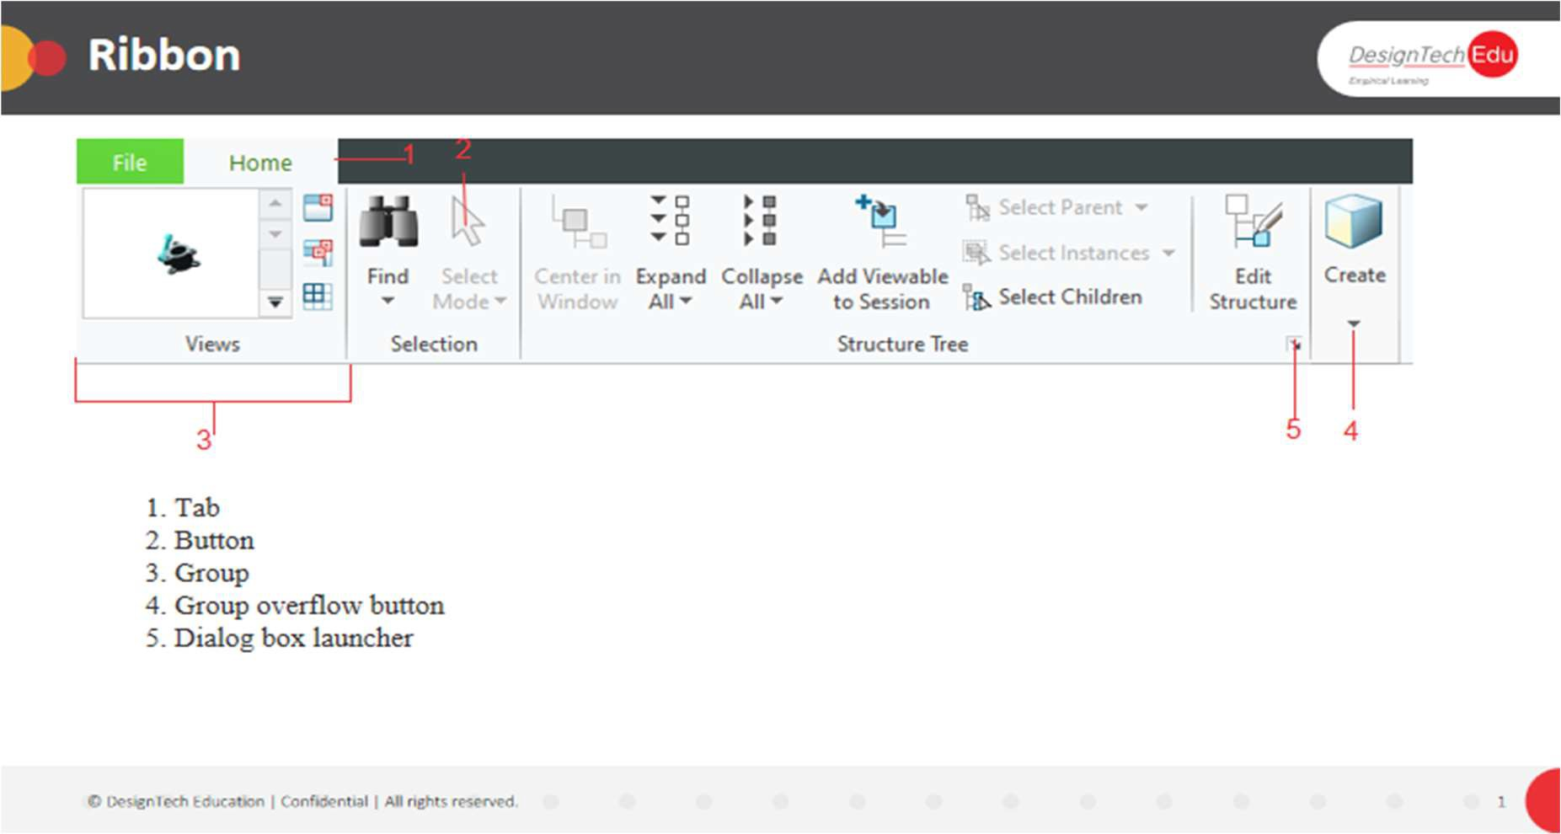

1. Tab
2. Button
3. Group
4. Group overflow button
5. Dialog box launcher

**Tab**

Some tabs are available when you are in a particular mode or application, or when you need them in a particular context. For example, the Structure and Model Parts tabs are commonly available MCAD tabs when a part is selected. For ECAD, the Annotations tab is available when an annotation is selected. Tabs related to a particular context open or close automatically when you activate or deactivate the context. Similarly, tabs related to a particular object open or close automatically when the related objects are selected or deselected. Tabs that contain tools of an application or controls of a tool have specific buttons to open and close them.

**Button**

By default, each button on the ribbon consists of an icon and a label. Some examples of buttons are shown below:

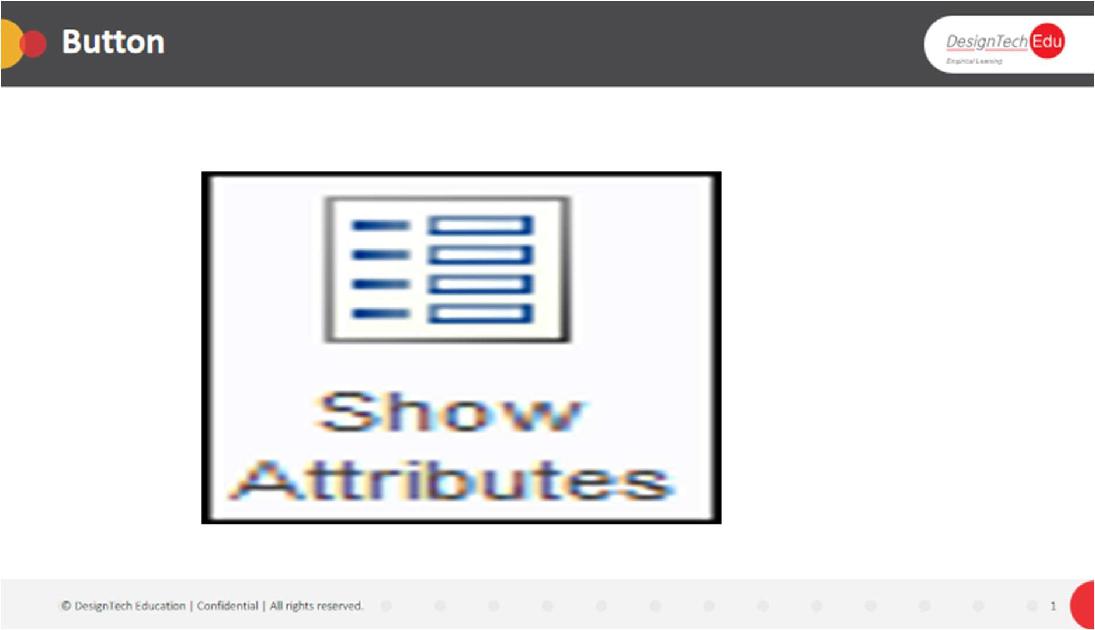

Button for a task

**Split Button**

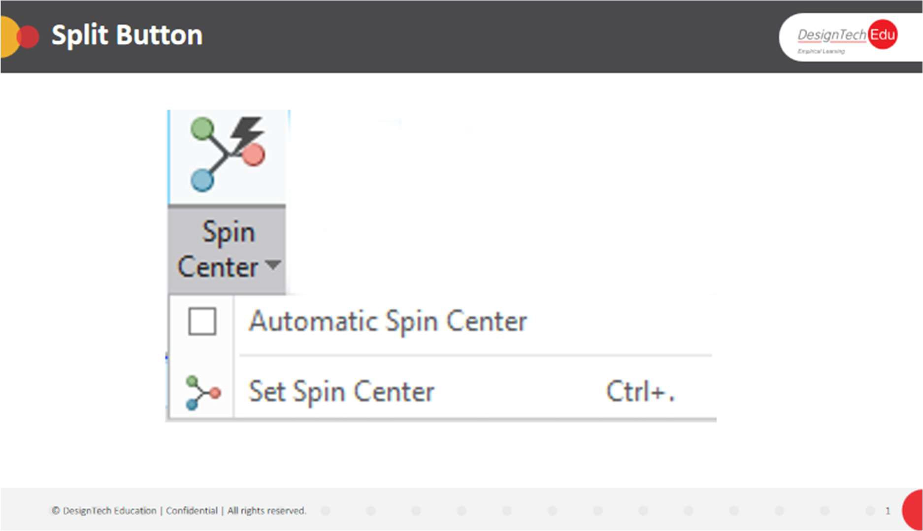

* Each portion performs a different task.
* One portion displays the default icon or the icon of the last selected button in the current session. Click the icon to run the command that the icon represents. The button label remains unchanged regardless of the last selection. However, the tooltip reflects the name of the tool that the icon represents.
* The other portion displays an arrow. Click the arrow to open a list of related buttons or a menu.

**Gallery**

The gallery provides a set of visual options.

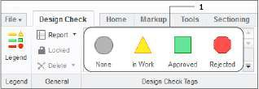

**Gallery**

**Dialog Box Launcher**

The dialog box launcher is a  button in the lower-right corner of some groups. Click  to open a dialog box with more options related to the group.

**To Customize the Ribbon**

You can customize the tabs, groups and buttons in the ribbon as follows:

* Add or remove buttons and groups from existing tabs
* Create new tabs
* Move buttons from a group to the overflow area
* Show or hide a button’s label
* Change the order of tabs, groups, and buttons
* Minimize or maximize the ribbon

You can perform some of these operations using the shortcut menu. Make other changes to the ribbon using the Creo View Options dialog box.

Export your custom user interface settings, including customizations of the ribbon and the Quick Access Toolbar, to a *.ui file. You can also import a *.ui file to apply its settings to your session of Creo View.

**To Customize the Ribbon using the Options Dialog Box**

Use the Creo View Options dialog box to make changes to the ribbon, as described below.

1. Right-click the ribbon and choose Customize the Ribbon from the shortcut menu. The Creo View Options dialog box opens to the Customize-Ribbon page.
2. Perform one or more of the operations below. Click OK when done.

**To Hide a Tab or Group**

In the Customize the Ribbon list on the right, clear the check box for the tab or group. To unhide, select the check box.

**To Rename a Tab or Group**

1. In the Customize the Ribbon list on the right, select the tab or group to rename.
2. Click Rename. The Rename dialog box opens.
3. Under Display name, type a new name, and then click OK. The name is updated. To Change the Order of Tabs, Groups, Buttons, or Cascades
4. In the Customize the Ribbon list on the right, select the tab or group to move.
5. Click  or  to change the position.

**To Add an Existing Group or Button**

1. In the Choose commands from list on the left, click the arrow. A list of locations, including ribbon tabs, is displayed.
2. Select the location that contains the group or button. The list of groups and buttons is displayed on the left.
3. Select the group or button to add.
4. On the right, in the Customize the Ribbon list, select a destination tab or group.
5. Click Add. The item is added to the selected location.

**To Remove a Group or Button**

1. On the right, in the Customize the Ribbon list, select the item to remove.
2. Click Remove. The group or button is removed from the ribbon.

**To Add a New Tab or Group**

1. On the right, under the **Customize the Ribbon** list, click one of these buttons:
   * **New Tab**—a tab is created with the name **New Tab**.
   * **New Group**—a group is created with the name **New Group**.
2. Reposition and rename the item, as described in the procedures above.

**To Define a New Cascade**

1. On the right, in the **Customize the Ribbon** list, select a user-defined group.
2. Click **New Cascade**. A new cascade button is added to the group.
3. Rename the cascade as described in the procedure above.
4. To modify the image for the cascade, follow the steps in “To Modify the Image for a Cascade” below.
5. To set the command displayed, click **Modify**. The **Modify** menu opens
6. Select one of these options:
   * **Display Menu**—Displays labels only.
   * **Display First Command**—displays the icon of the first button, regardless of the last- selected button.
   * **Display Last Used Command**—displays the icon of the last selected button.

**To Modify the Button Style**

1. On the right, in the **Customize the Ribbon** list, select a button name, and then click **Modify**. The **Modify** menu opens.
2. Select one of these options for display:
   * **Default Style**—Default appearance.
   * **Small Button**—Small-sized button.
   * **Small Button**-**No Icon**—Small label with no image.
   * **Large Button**—Large-sized button.
   * **Hide Command Label**—Image with no label.

**To Modify the Image for a Cascade**

1. On the right, in the **Customize the Ribbon** list, select a cascade name, and then click **Modify**. The **Modify** menu opens.
2. Select options in the menu as needed:
   * **Copy Button Image**—Copies the image of the selected button.
   * **Paste Button Image**—Pastes the copied image.
   * **Reset Button Image**—restores the default image.
   * **Choose Button Image**—Opens the **Open** dialog box. Browse to the location of a new image, and then click **Open**. You can automatically resize images that do not match the button size you set.
   * **Edit Button Image**—Opens the **Button Editor** Dialog box. Select colors, draw, and move the image up, down, right, or left. Click **OK**.

**To Move Buttons to or from the Overflow**

1. To add a button to the overflow, on the ribbon, right-click the button and choose Move to overflow from the shortcut menu. The button is moved. For the first button added, an overflow arrow appears next to the group name.
2. To move a button back to its group, in the overflow, right-click the command and choose Move to Group from the shortcut menu. The button appears in the ribbon group.

To Minimize or Maximize the Ribbon

Toggle the ribbon by doing one of the following operations:

* Double-click the name of an active tab.
* Right-click the ribbon or the Quick Access Toolbar and select or clear the Minimize the Ribbon check box in the shortcut menu.
* Press CTRL+F1.

The ribbon is minimized or maximized.

**To Export Custom User Interface Settings**

1. Right-click the ribbon and choose Customize the Ribbon from the shortcut menu. The Creo View Options dialog box opens to the Customize-Ribbon page.
2. On the right, under Customize the Ribbon, click Import/Export > Export all Ribbon and Quick Access Toolbar customizations. The Export dialog box opens.
3. Accept the default directory, \User Profiles\<current user>\My Documents, or browse to a new location.
4. Accept the default file name, ui gallery _ customize. ui, or type a new name in the File name box.
5. Click Save. The settings are saved.

**To Import Custom User Interface Settings**

* 1. Right-click the ribbon and select customize the Ribbon. The Creo View Options dialog box opens to the Customize-Ribbon page.
  2. On the right, under Customize the Ribbon, click Import/Export > Import customization file. The Open dialog box opens.
  3. Browse to the *.ui file to import, and then click Open.
  4. Select a file to import, and then click OK. The file is imported.

**To Restore the Default User Interface Settings**

1. Right-click the ribbon and choose Customize the Ribbon from the shortcut menu. The Creo View Options dialog box opens to the Customize-Ribbon page.
2. On the left, under the Choose commands from list, click Reset to Default. The default settings for the ribbon are applied.

**To Customize Commands using the Options Dialog Box**

Use the **Creo View Options** dialog box to create, edit, or delete customized commands.

1. Click **File** > **Options**.

The **Creo View Options** dialog box opens.

1. On the left, under **Customize**, select **Custom Commands**. The **Customize**-**Custom Commands** options open on the right.
2. Add a new customized command, as follows:
   1. Click **Add** and choose an option:
      * **Empty**—to add a new command with no command definitions.
      * **Minimal**—to add a new command with minimal commands definitions.
      * **Most Options**—to add a new command with all available options defined.
   2. In the **Edit Custom Command** window, edit the **Command Definition** and click **OK**. A new command is added.
3. To delete a command, select it and click **Delete**.
4. Edit an existing command, as follows:
   1. Select the custom command you wish to edit and click **Edit**. If a lock appears under **Editable**, you may view the XML code but not edit it.
   2. In the **Edit Custom Command** window, edit the **Command Definition** and click **OK**.
5. Click **OK** to apply the changes and close the dialog box, or click **Apply** to apply the changes and keep setting options.

**CHAPTER 2 - CUSTOMIZATION**

**About the Quick Access Toolbar**

The Quick Access Toolbar is located at the top of the Creo View window. By default, it contains the following commonly-used commands:

• —Delete

• —Redo

• 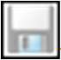—Save All

• —Undo

• —Customize

You can make the following changes to customize the toolbar:

* Move the toolbar
* Add commands
* Remove commands
* Import settings

Use the **Creo View Options** dialog box to customize the Quick Access Toolbar. The dialog box contains a list of the available commands:

* Commands are sorted according to their location on the ribbon.
* When you select a tab name from the box, the buttons on that tab appear in the list.
* The tooltip for each button in the list shows the menu path to the button.
* A command name with a downward arrow is a cascade.
* A command name with an arrow pointing right is a ribbon group.

The **Creo View Options** dialog box also contains a list of the commands currently included on the toolbar.

After you customize the Quick Access Toolbar, you can export your settings to a User Customization File (*.ui).

**Quick Access Toolbar**

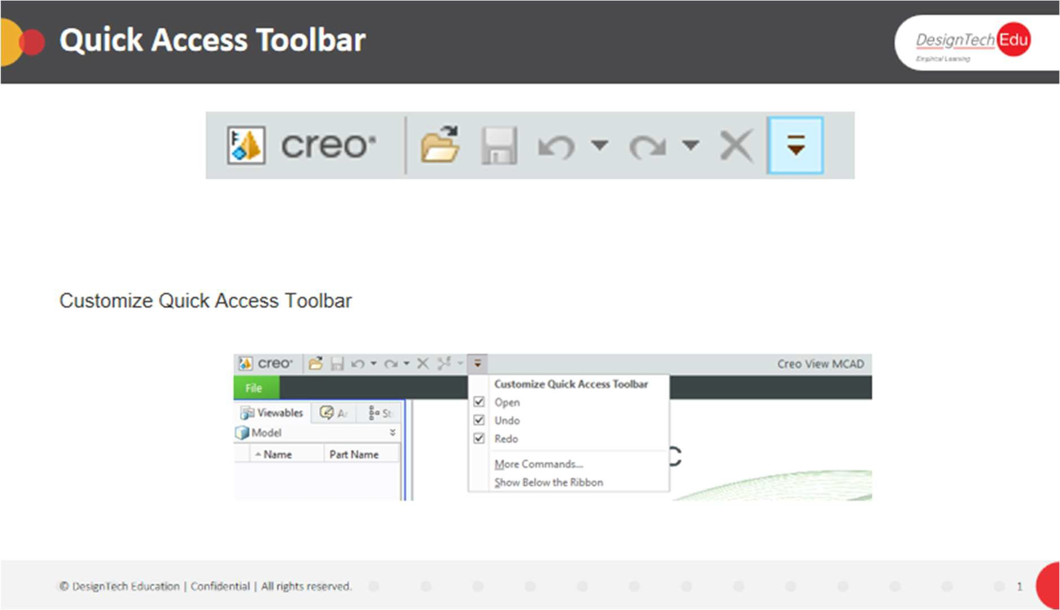

**To Add a Command to the Quick Access Toolbar**

To add a command from the ribbon or from a dialog box, right-click the command and choose **Add to Quick Access Toolbar** from the shortcut menu. The command is added. Alternatively, follow the steps below.

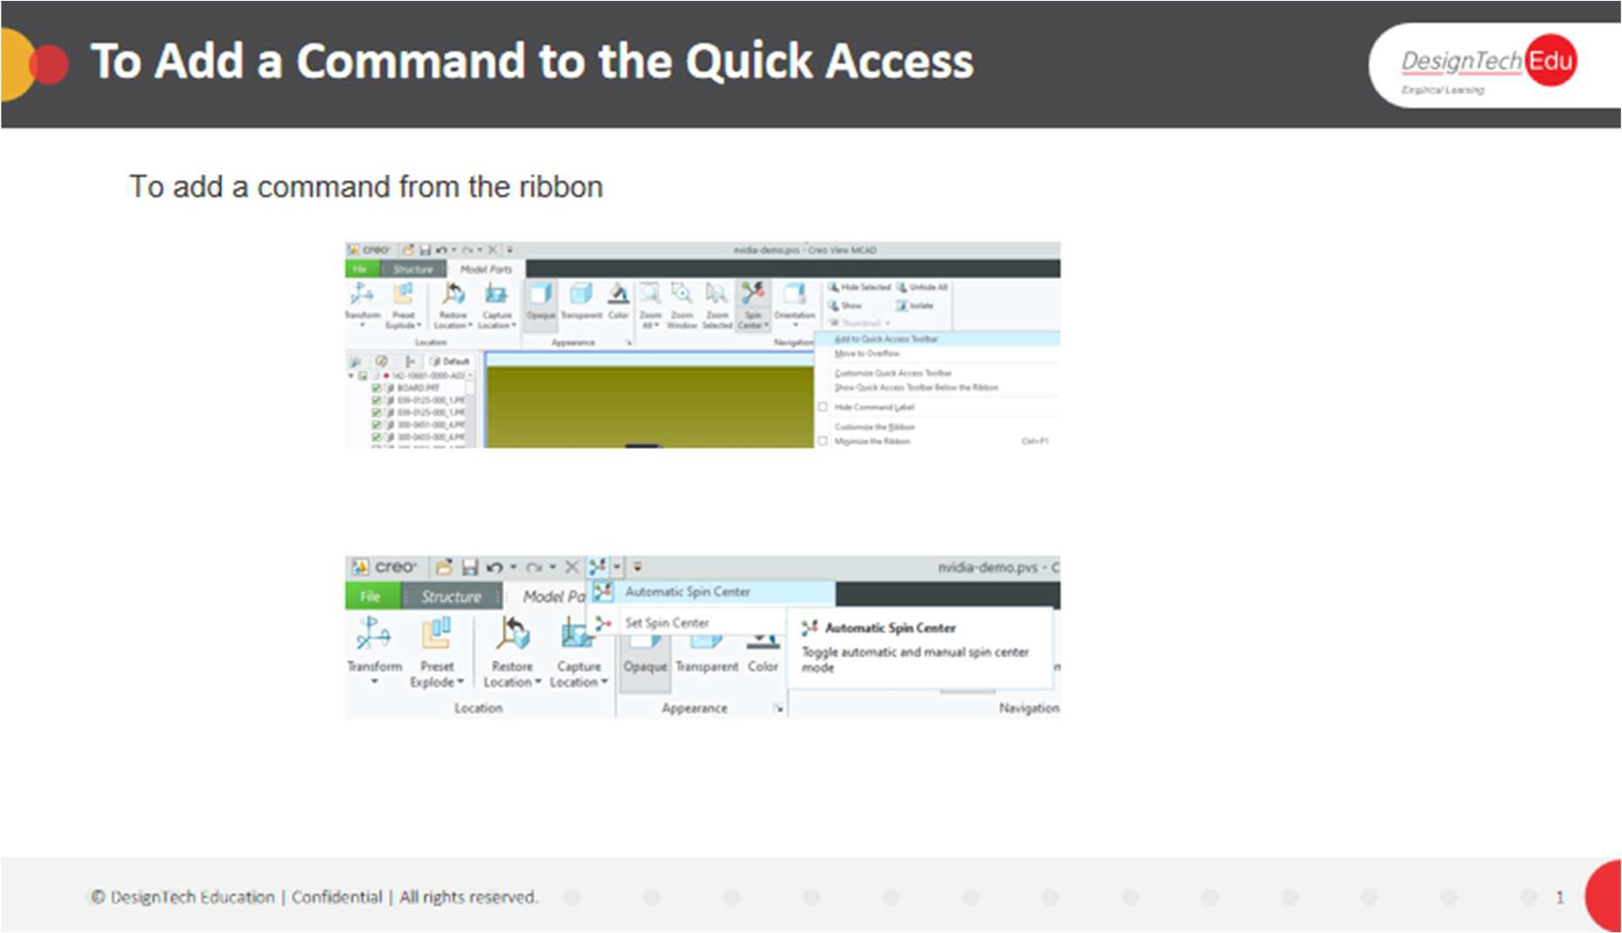

1. On the Quick Access Toolbar, click . The **Customize Quick Access Toolbar** menu opens.
2. Select one of the common commands from the menu to quickly add it, or click **More Commands** The Creo View **Options** dialog box opens to the **Customize**—**Quick Access**

**Toolbar** page.

1. In the **Choose commands from** box, select a list of commands. The command list is displayed in the box on the left.
2. Select a command and click **Add**. The command is added to the **Customize the Quick Access Toolbar** box on the right.
3. Repeat step 4 for each command to add.
4. To add a separator between buttons, select <Separator> from the top of any ribbon’s command list, and then click **Add**.
5. To reposition a button or a separator, in the **Customize the Quick Access Toolbar** box on the right, select the name of the button or separator and click  or  to move it in the list.
6. Click **Apply** to apply the changes and continue setting options, or click **OK** to apply the changes and close the dialog box.

**To Customize Quick Access Toolbar**

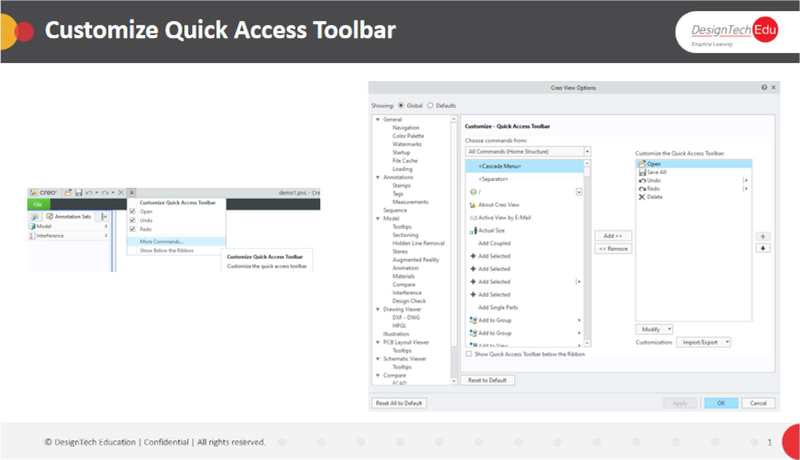

**To Remove a Command from the Quick Access Toolbar**

On the Quick Access Toolbar, right-click the command and choose **Remove from Quick Access Toolbar**. The command is removed. Alternatively, follow the steps below.

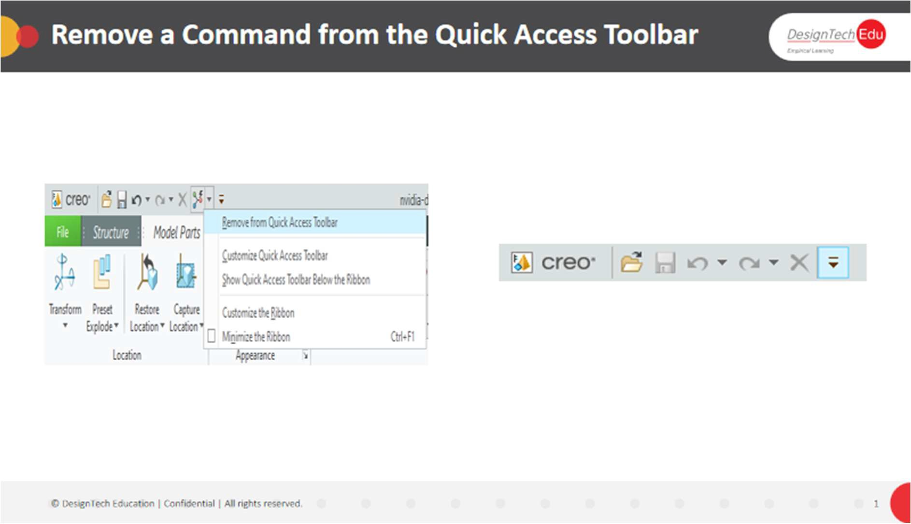

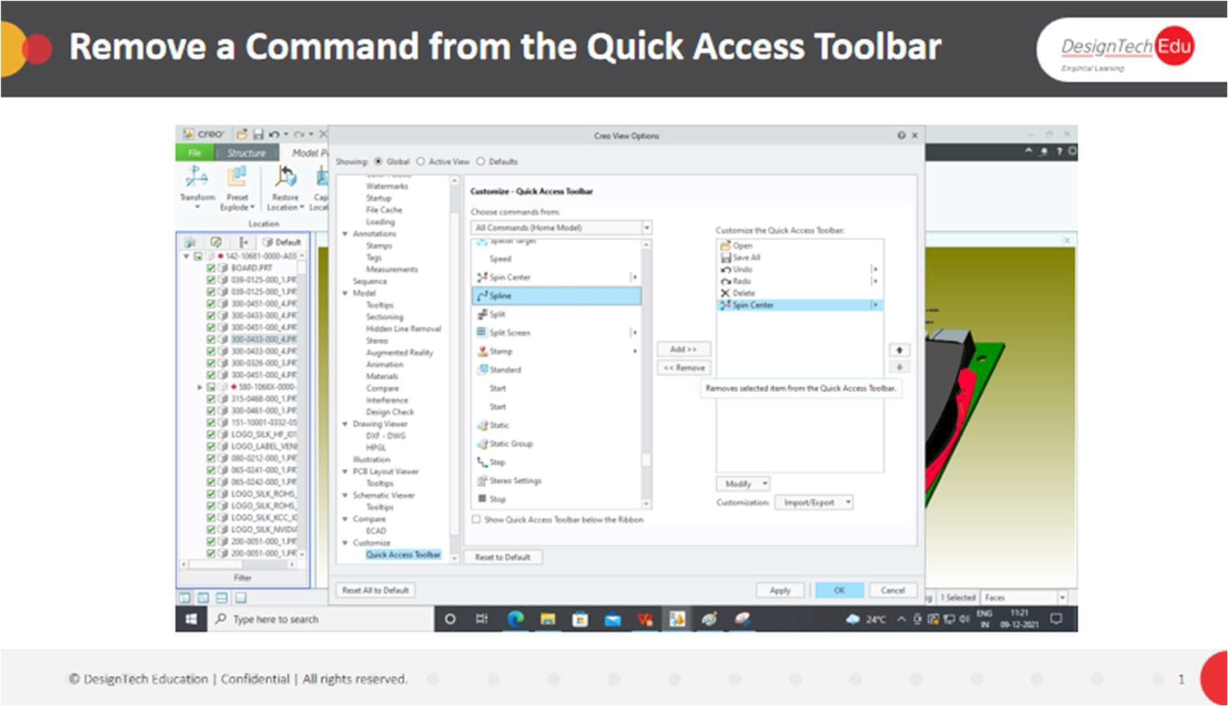

1. Open the **Customize**-**Quick Access Toolbar** page of the **Creo View Options** dialog box in one of these ways:
   * Right-click the Quick Access Toolbar or the ribbon and choose **Customize Quick Access Toolbar** from the shortcut menu.
   * On the Quick Access Toolbar, click, and then choose **More Commands** from the menu.
2. Select a command from the **Customize Quick Access Toolbar** list on the right, and then click **Remove**. The command is removed.
3. Click **Apply** to apply the settings and keep the dialog box open, or click **OK** to apply the settings and close the dialog box.

**To Move the Quick Access Toolbar**

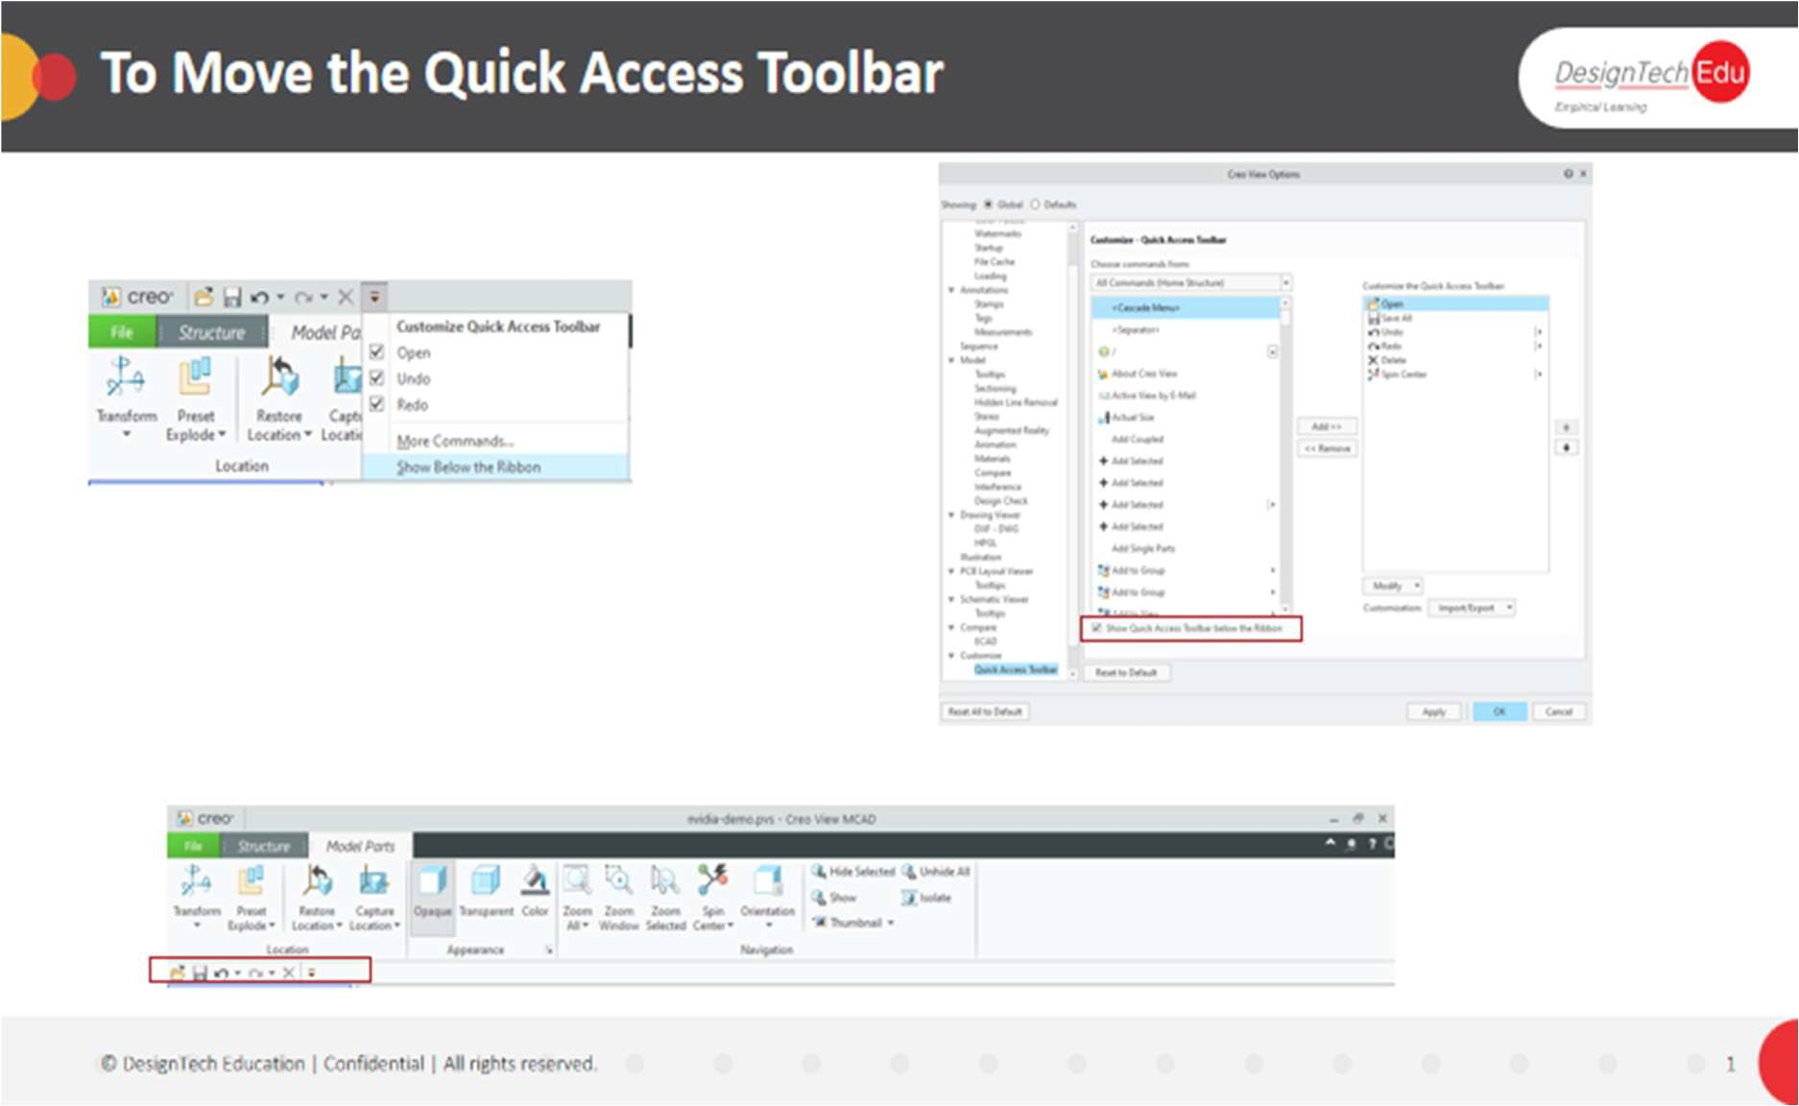Right-click the ribbon and choose Show Quick Access Toolbar below the Ribbon or Show Quick Access Toolbar above the Ribbon. The toolbar is moved. Alternatively, follow the steps below.

1. On the Quick Access Toolbar, click. The Customize Quick Access Toolbar menu opens.
2. Select Show Quick Access Toolbar Below the Ribbon or Show Quick Access Toolbar Above the Ribbon. The toolbar is moved.

**About Customizing the Palette**

The Creo View palette includes 16 basic colors. In Creo View you can add any number of custom colors. Set the palette to display all colors or only custom colors.

Use the Creo View Options menu to create, save, and edit new colors or to delete them. You can also add a name to each color that appears in a tool tip. In Creo View Lite, you can view custom colors, but you cannot modify the palette.

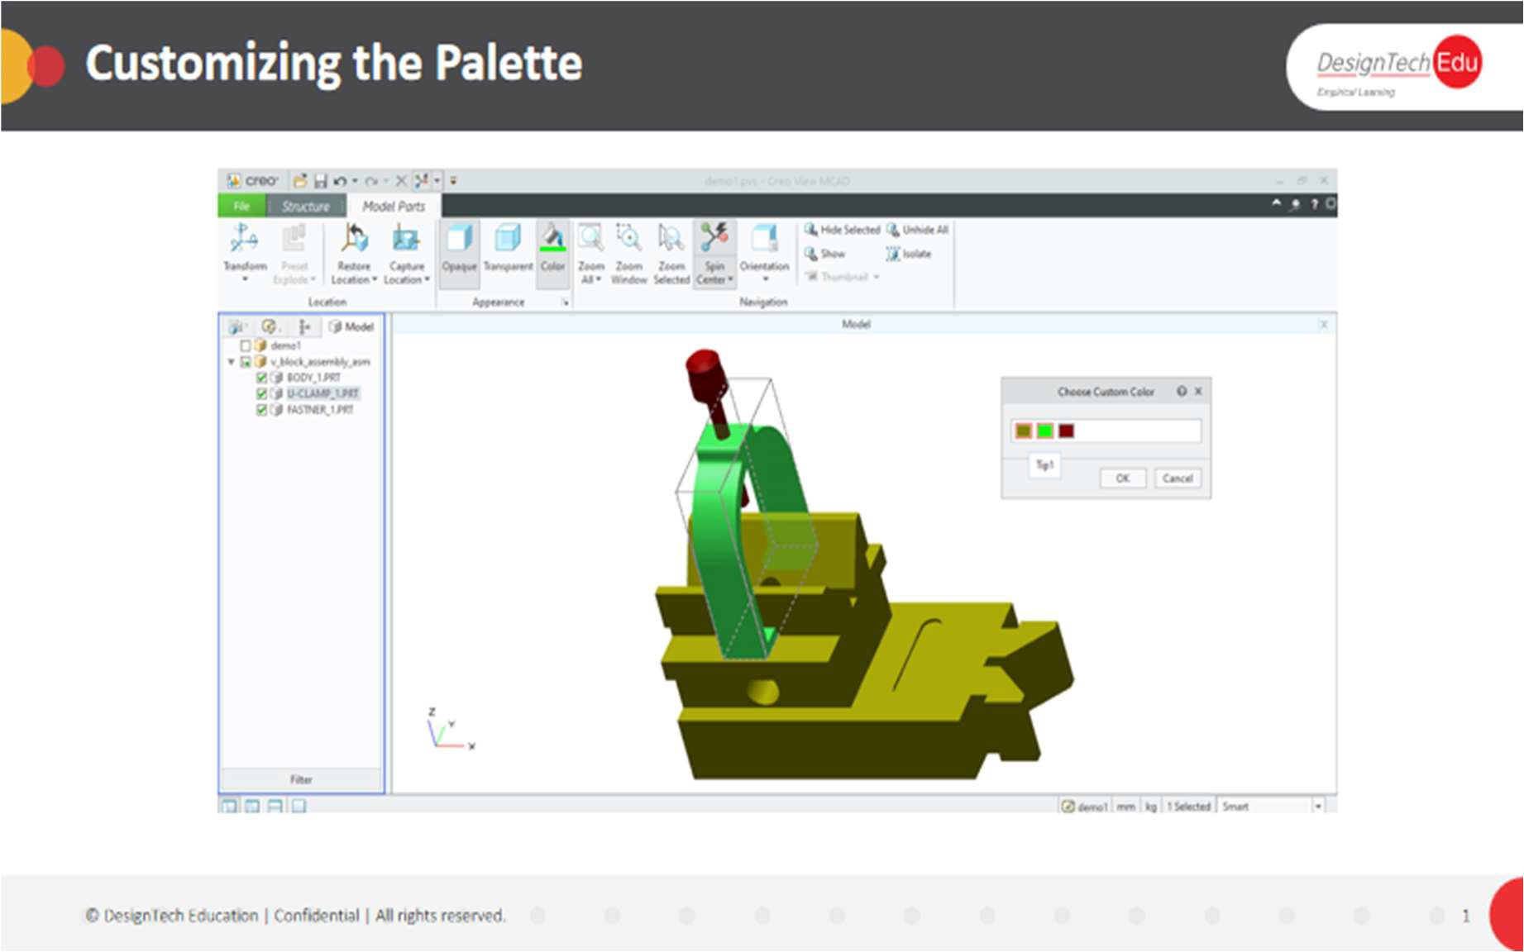

**To Add Custom Colors to the Palette**

1. Click File > Options. The Creo View Options dialog box opens.
2. Next to Showing, select Global.
3. On the left, under General, select Color Palette. On the right, the General-Color Palette options open.
4. Click Add. The Choose Color dialog box opens.

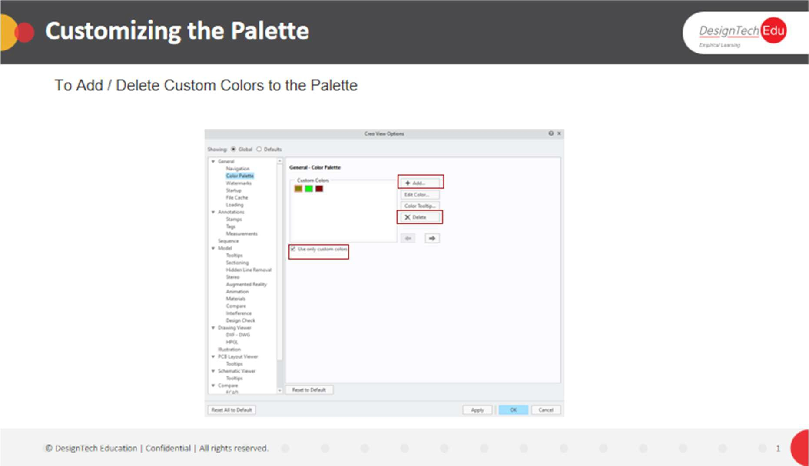

1. Set a color, and then click OK.
2. Repeat steps 5–7 for each custom color.
3. To add a tooltip, select a color and click Color Tooltip. The Name Color dialog box opens.
4. Type a name in the Text box, and then click OK.
5. To exclude the basic colors from the palette, in the Creo View Options dialog box, select the Use only custom colors check box.
6. Click OK.

**To Edit or Delete Custom Colors**

1. In the Creo View Options dialog box, under the General-Color Palette options, select a color to edit and click Edit Color.
2. Adjust the Red, Green, and Blue values, and then click OK. The color is edited.
3. To delete a custom color, select it and click Remove. The color is deleted.

**About Creo View Formats**

Creo View files use the following suffixes:

|  |  |  |
| --- | --- | --- |
| Type | Extension | Double precision storage format |
| Structure | *.pvz  *.ed  *.edz | Available |
| 3D model | *.o1 | Available |
| Annotation | *.pva |  |
| Interference | *.pvc |  |
| PCB schematic Layout compressed package  with one or more of the types above | *.eda |  |

**About Opening Structures and Designs**

You can open files that contain MCAD data, ECAD designs, or both. The **File** menu contains a list of recently opened files. Open Creo View files, or import one of the supported external formats.

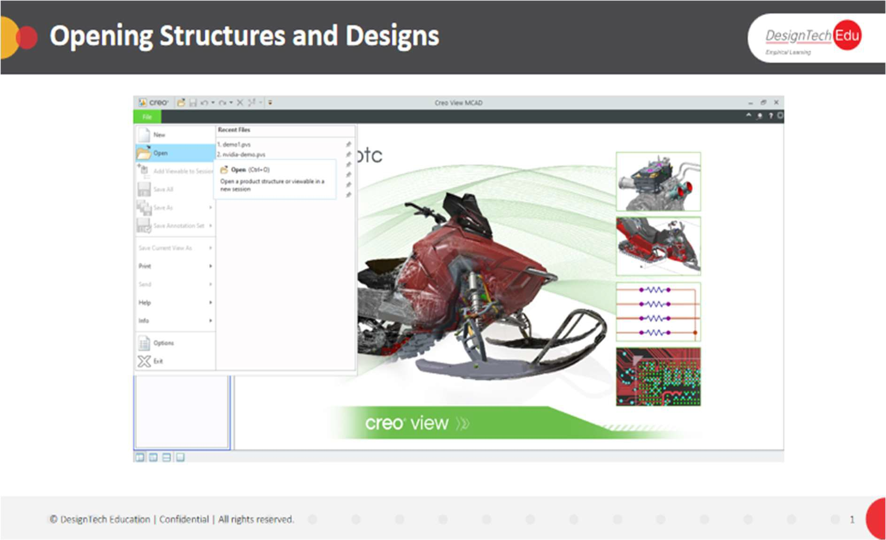

When you open a file, you may be required to accept a copyright notice before it is loaded. You can view copyright and other file information about loaded files by selecting **File** > **Info**.

When you open a file, it is not automatically loaded. Instead, you can select one or more viewables in the file to load. In MCAD structures, within the model view, you can select one or more parts or subassemblies to load, or you can load the entire structure. A Creo View structure contains information about the makeup, organization, and appearance of the parts of a product. In Creo View, you can edit the structure of a product. A structure file has one or more of the following MCAD viewables:

* Model
* Image
* Drawing
* Document
* 2D Illustration
* 3D Illustration

A structure can also have one or more of the following ECAD viewables:

* Schematic
* PCB Layout
* Overlay

After you open the structure, you can open one or more viewables associated with it. In addition to viewable files, the following information can be linked to the structure file:

* Appearance of parts
* Markups
* Attributes
* Groups of parts
* Sections

**To Open a Structure or Design**

1. Click Open. The Open File dialog box opens.
2. Select the folder that contains the structure or design file to open, or type a name in the Search box.
3. To filter the files by type, select a file type from the Type box.
4. Select the file, and then click Open.

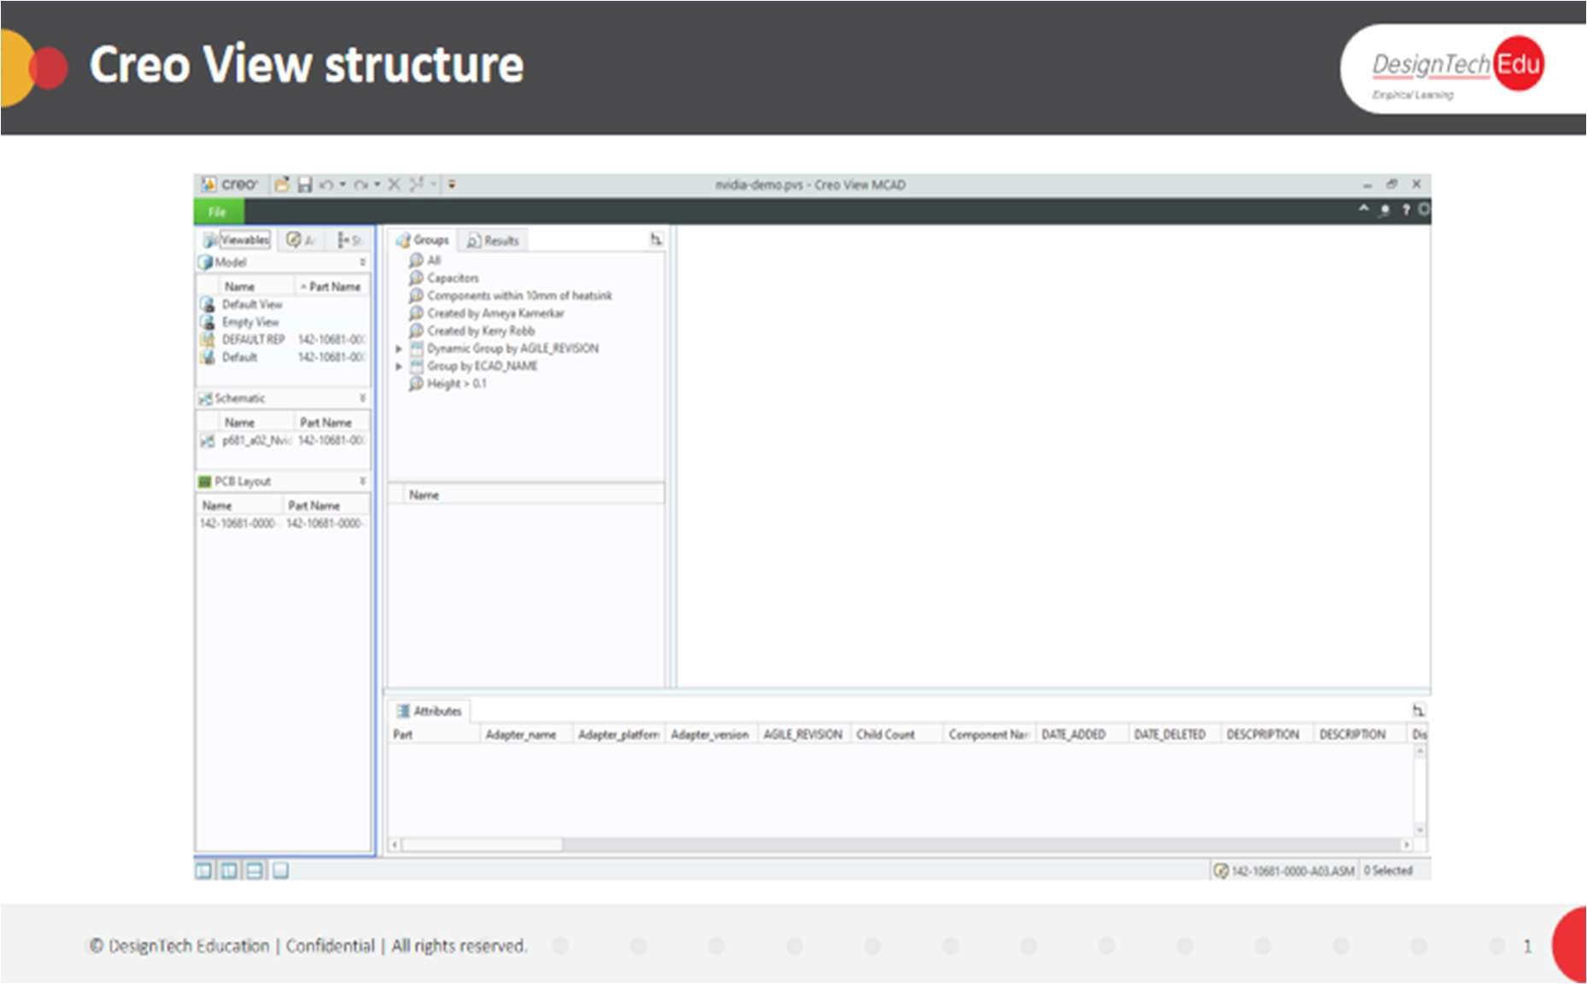

**About Opening Files with Copyrights**

Acceptance of Copyright notices may be required before displaying or using OL files in Creo View. If so, when they are loaded into Creo View, a warning dialog opens asking you to accept or reject the copyright for that file.

If you accept the copyright, the file is loaded and that particular copyright is not requested again in that session.

If you reject the copyright, the file does not open, no files with that copyright open during that session, and a special icon indicates rejected copyrights in the sBOM Tree.

If you mistakenly declined a copyright then you may choose to accept it by clicking on a part with the declined copyright symbol in the tree to reload it and show the copyright notice once again.

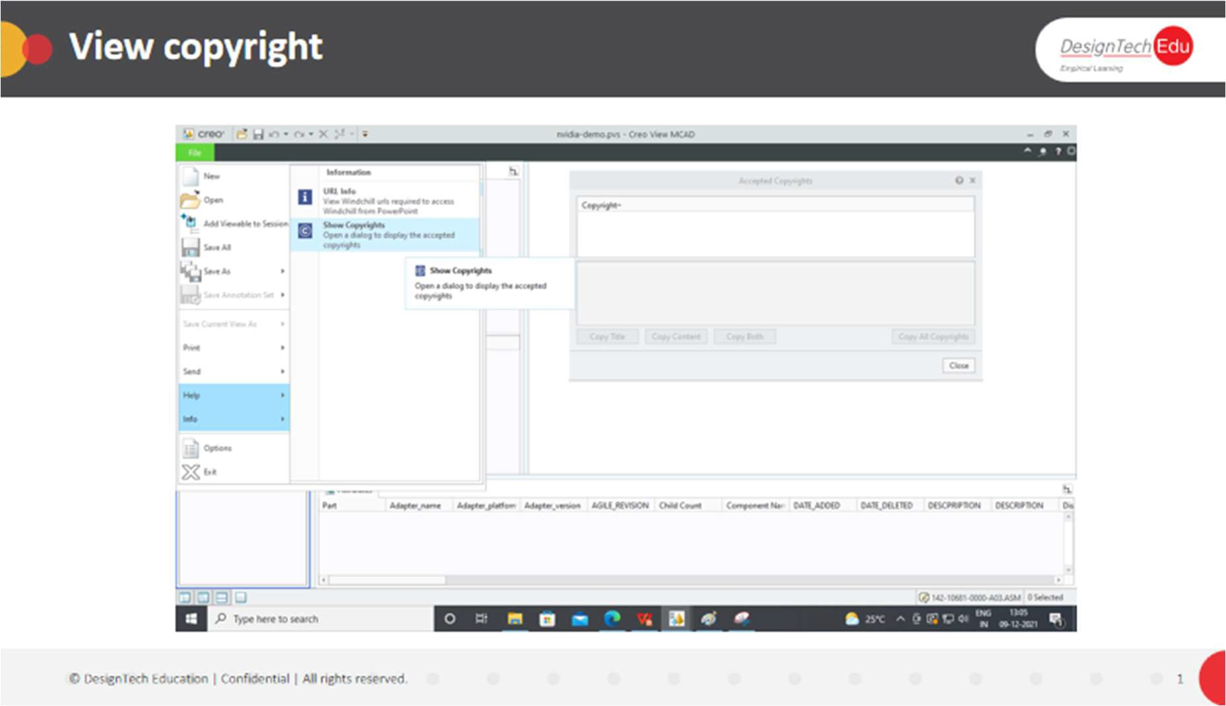

**To View Accepted Copyrights**

1. Click **File** >  **Info** >  **Show Copyrights**. The **Accepted Copyrights** dialog box opens.
2. Select one or more copyrights from the list and click **Copy Title**, **Copy Content**, or **Copy Both**, to copy the required content to a clipboard.
3. Click **Copy All Copyrights** to copy all the copyright content to a clipboard.
4. Click **Close**.

**To View Loaded File Information**

You can view file information about loaded files by selecting File >  Info, and then selecting  Info. The Information page is displayed.

**About Adding or Deleting Viewables**

You can add a viewable to the session. Depending on your data, the viewable is added to these locations:

* MCAD—Selected location in the Structure Tree. If you do not select a location, the viewable appears at the bottom of the tree. You can also insert one or more viewables of different types into the root of the structure, and then merge and reposition them.

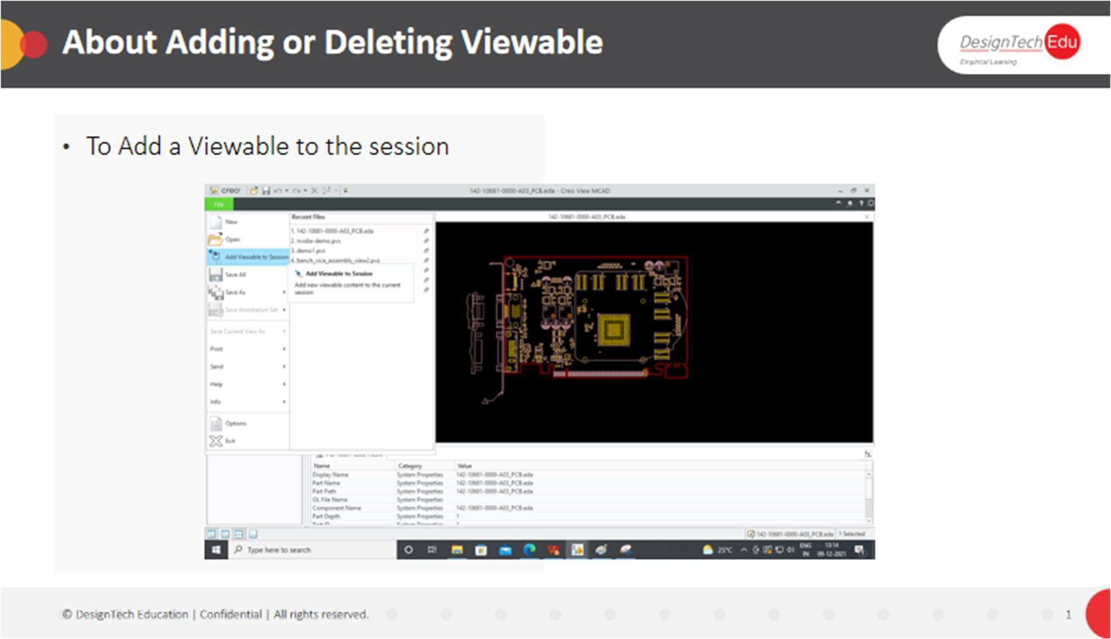

* ECAD— **Viewables** tab of the primary panel.

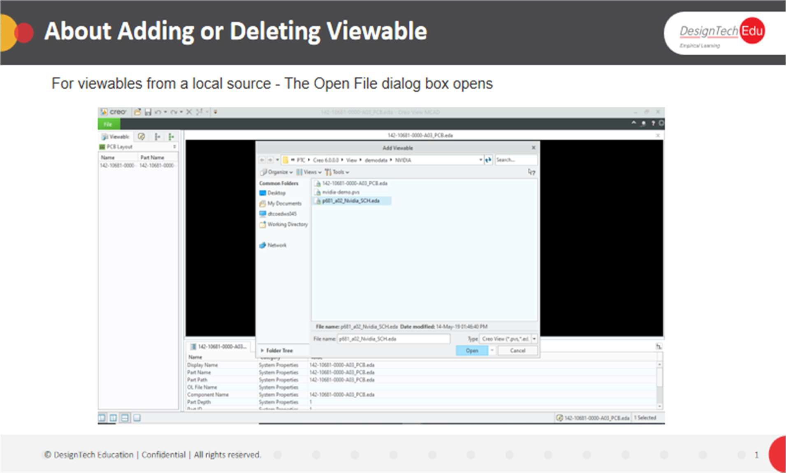

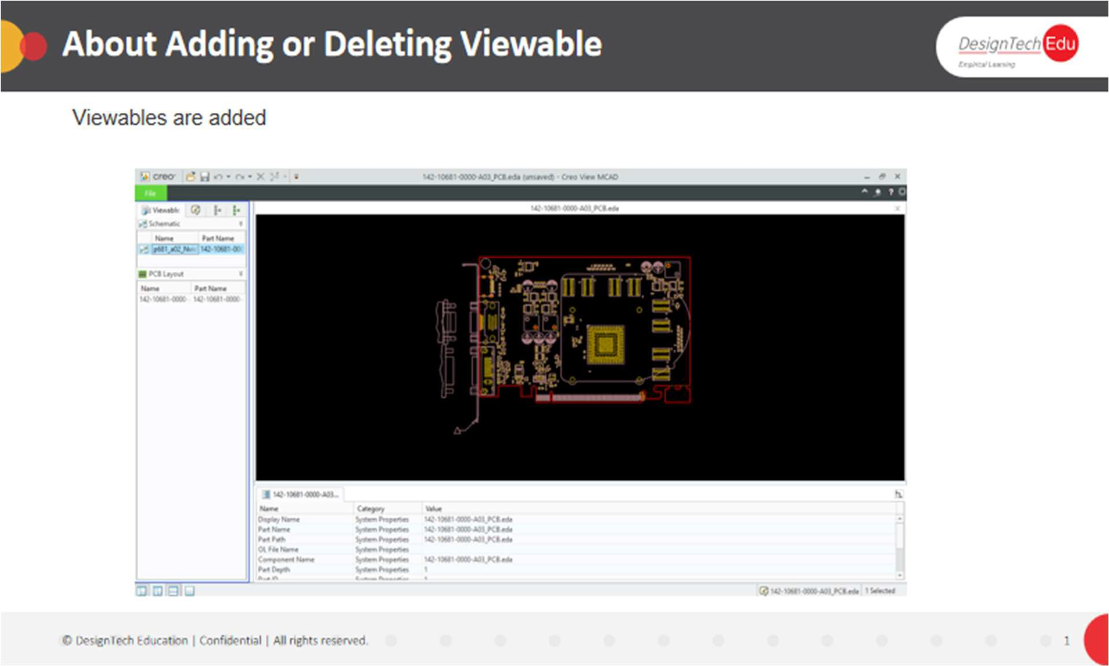

You can remove viewables from the Structure Tree and keep the original node.

For data opened from Windchill, you can add viewables from a local source and work on the integrated data, but you cannot save the integrated structure locally or to Windchill. You must save the structure before adding viewables from a local source. You can save an integrated structure only as an annotation set, or save a copy locally.

**To Add a Viewable to the Session**

This procedure applies for local files and files opened from Windchill.

1. Click **File** > 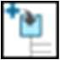 **Add Viewable to Session**.
   * For viewables from Windchill:
2. The **Import When Connected to Windchill** dialog box opens.
3. Click **Save** to save changes that you made, or **Do Not Save** to discard the changes. The **Open File** dialog box opens.
   * For viewables from a local source—The **Open File** dialog box opens.

2. Select one or more files and click **Open**. The viewables are added.

**Bodies in Creo View**

**About Working with Parts with Bodies**

Creo View supports loading geometric multibody data and represents bodies in the Structure Tree.

Geometric bodies are represented as a node under the respective multibody part.

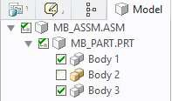

**To Control the Listing of Bodies in the Structure Tree**

In Creo View part bodies appear in the Structure Tree by default, or you can set an option to hide the bodies in the Structure Tree. Complete the following steps if you do not want part bodies to appear in the Structure Tree:

1. Click **File** > **Options**. The **Creo View Options** dialog box opens.
2. Next to **Showing**, click **Global**. The global options list appears on the left.
3. On the left, under **General**, click **Navigation**. The **General** –**Navigation** options appear.
4. Clear the **Display part bodies** check box.
5. Click**Apply**to keep the**Options**dialog box open, orclick**OK**to apply theoptionsand close the dialog box.

**To Use Selection Filter When Working With Bodies**

1. On the status bar, select the **Bodies** selection filter.
2. In the graphics area, move the pointer over the body. The entire part is highlighted.
3. Select the body. The entire part is highlighted.
4. Select the body again. Only the body is highlighted, and its sibling is no longer highlighted.

**To Include Bodies in a Search**

To include bodies when searching with MCAD attributes, follow these steps:

1. Click**Home** > **Find** > **Search**.The **Search Product Structure** dialog box opens.
2. In **Do query of type**, select **Attribute**. The dialog box updates.
3. Select the **Include Bodies** check box.

**CHAPTER 3 - IMPORTING AND EXPORTING FILES**

**About Importing and Exporting Files**

You can import external MCAD or ECAD files, add annotations, and save the file as a Creo View file. By default, the import filters for most external formats are automatically installed and configured when you install Creo View. These are the exceptions:

* The JT filter must be manually installed.
* Some ECAD filters require manual configuration using a configuration tool. You can customize the installation to include only the import filters you need.

In Creo View, you can export Creo View MCAD structures to 3D files, and you can export MCAD and ECAD views to these types of 2D files:

* Vector
* Image

**Saving Files**

**About Saving External File Formats in Creo View**

You can save external files that you open as Creo View files.

In Creo View Lite and Creo View, you can save data to the following formats:

* PVZ—Includes files for all viewables and annotations
* PVS—Saves the information as a directory and references the viewable and annotations files The following ECAD file types are not saved as EDA files when you save the structure:
* Gerber
* ODB++
* IDF

Instead, the resulting PVZ or PVS file includes or references the native file for these viewables.

In Creo View, you can save MCAD files as image files, 2D vector files, or 3D files, and ECAD files as image files or EDA files.

**To Save an External File Format in Creo View**

1. To overwrite the current structure, click **File** > **Save All**. The files are saved.
2. To create a new structure, click **File** > **Save As**, and then click one of these options:
   * **Save All As PVS**
   * **Save All As PVZ**
   * **Save Copy Of All As PVS**
   * **Save Copy Of All As PVZ**

The **Save As** dialog box opens. Proceed to Step 5.

1. To save an ECAD view as an EDA file, when working in Creo View, click **Save Current**

**View As** > **As an EDA file**.



The image part w ith relationship ID rId48 w as not found in the file.

1. The **Save View as EDA** dialog box opens.
2. Select a location for the file.
3. In the **File name** box, accept the default file name, or type a new one.
4. Click **Save**. **Supported File Types**

You can view file formats from the following sources in Creo View:

* Model
* Drawing
* Document
* Image
* Illustration
* PCB Layout
* Schematic

**To Save a View as a VRML or 3D DXF File**

1. Click File > Save Current View As > Save As 3D. The Save View As 3D dialog box opens.
2. In the File name box, type a name or accept the default.
3. In the Type box, select a file format:
   * VRML
   * DXF
4. Click Save. For large files, the Save View As 3D dialog box opens with a progress bar.

**To Save a View as a JT, STEP, or IGES File**

1. Click File > Save Current View As > Save As 3D. The Save View As 3D dialog box opens.
2. In the File name box, type a name or accept the default.
3. In the Type box, select a file format:
   * JT
   * STEP
   * IGES
4. Click Save. The settings dialog box opens.
5. Under Save, select the parts to save:
   * Visible
   * Selected
   * All
6. For JT files, to include the BREP geometry, select the Include BREP check box.
7. For IGES files, under Format, select Single File or Multiple Files.
8. To preserve the hierarchy of the product structure, select the Include structure to root check box.
9. Click Save. For large files, the Save View As 3D dialog box opens with a progress bar.

**To Set Image Generation Preferences**

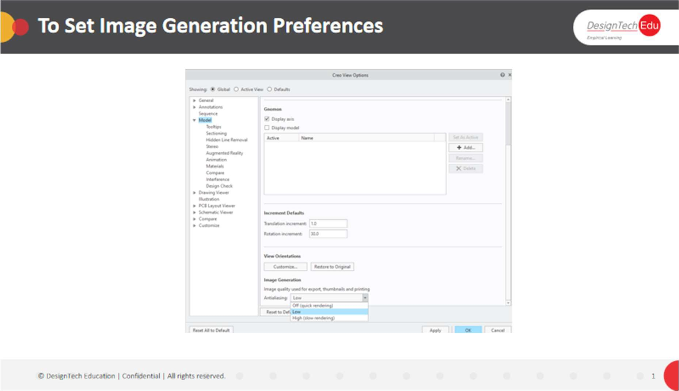

1. Click File > Options.

The Creo View Options dialog box opens.

1. Next to Showing, select Global. The General-Main options dialog box opens.
2. In the left pane, select Model. The Model-Main options open on the right.
3. Under Image Generation, select one of the following options from the initialising menu:
   * Off (quick rendering)
   * Low
   * High (slow rendering)
4. Click Apply to apply the settings and keep the Creo View dialog box open, or click OK to apply the settings and close the dialog box.

**About Annotation Sets**

**CHAPTER 4 – ANNOTATION**

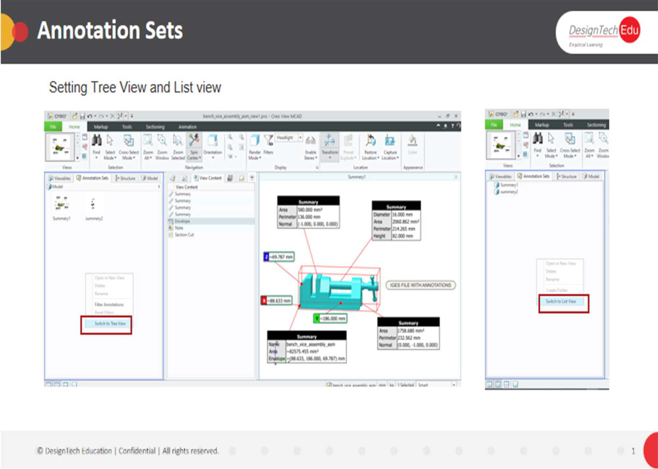

An annotation set is a group of saved markups. You can set one annotation set as the default so that it opens when you load the design. An asterisk preceding the annotation set name in the Annotation Sets pane indicates the default annotation set. When you save an annotation set, the file is saved with the structure or design file. You can change the structure path to save new annotation sets to another structure item provided that they are loaded from Windchill and they are top-level branch links. You must save an external file in a Creo View format (PVS or PVZ) before you can add and save an annotation set. You can create annotation sets in Creo View when working both with MCAD structures and ECAD objects. When working in Creo View Lite with MCAD structures you can create annotation sets, but when working with ECAD

objects you can only view annotation sets. Annotation sets are on the  **Annotation Sets** pane of the upper data panel. The pane has two display modes:

* List View—Displays thumbnail previews of the annotation sets.
* Tree View—Lists the names of the annotation sets and annotation folders. You must be in Tree View to create, view, edit, and delete annotation folders.

These markups are saved to an annotation set:

* Annotations
* Measurements
* Construction geometry (MCAD only)

Animate the transition between animation sets by setting a **Loading** option. You can merge MCAD annotation sets and views by applying an annotation set to a base view or annotation set. In Creo View ECAD, additional properties are saved to the annotation set:

* Color and Visibility settings
* Navigation settings
* Highlights
* Isolation
* Overlays
* Images

**To Open an Annotation Set**

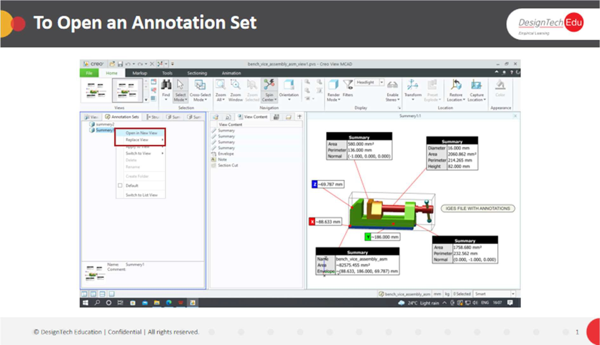

In the primary panel, click  **Annotation Sets**, and then perform one of these operations:

* Double-click the annotation set.
* Drag the annotation set into the graphics area.
* Right-click the annotation set and choose **Open in New View** from the shortcut menu.
* Right-click the annotation set and choose **Replace View** from the shortcut menu, and then select a view name to replace with the annotation set view.

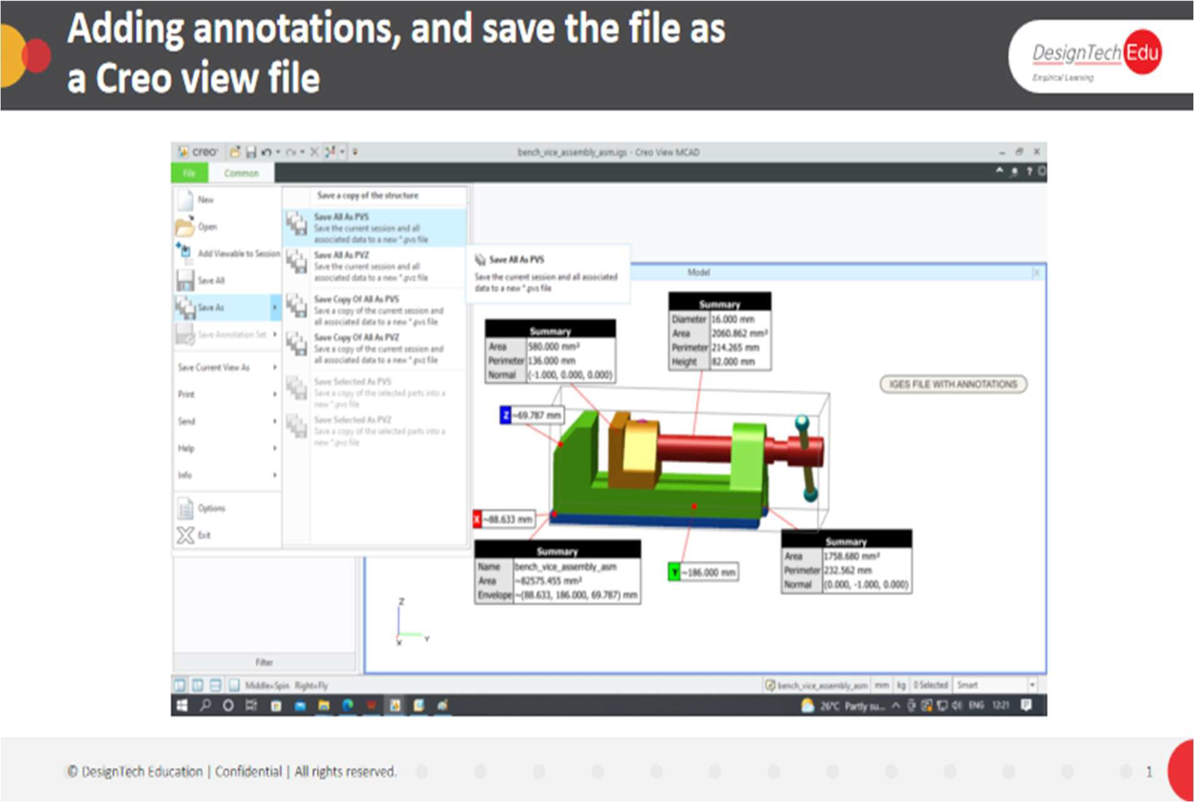

**To Save an Annotation Set**

1. Click **File** > **Save Annotation Set** or **File** > **Save Annotation Set As**. The **New Annotation Set** dialog box opens.
2. Type information in one or more of the following boxes:
   * **Name**
   * **Author**
   * **Telephone**
   * **E-Mail**
   * **Comments**
3. Click **OK**.

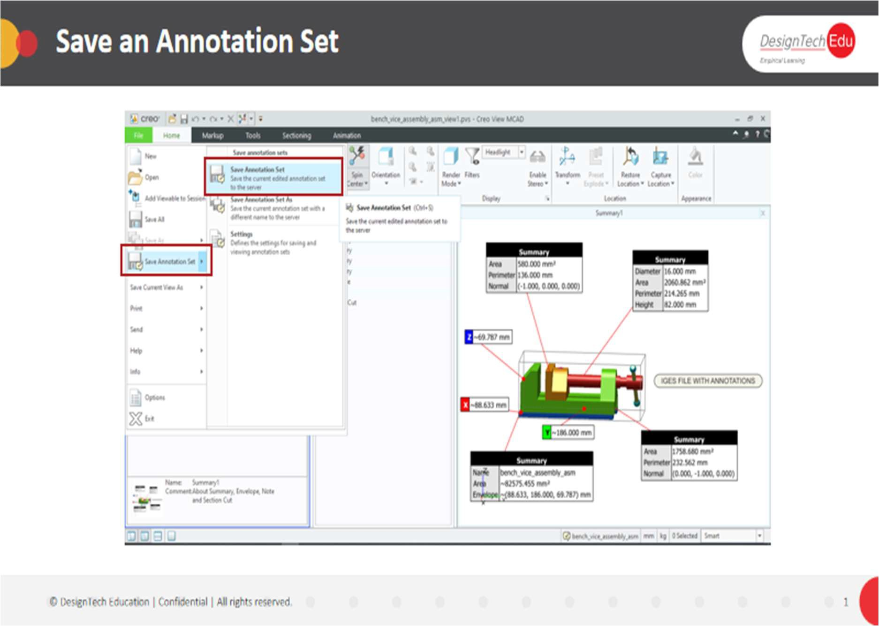

**To Create an Annotation**

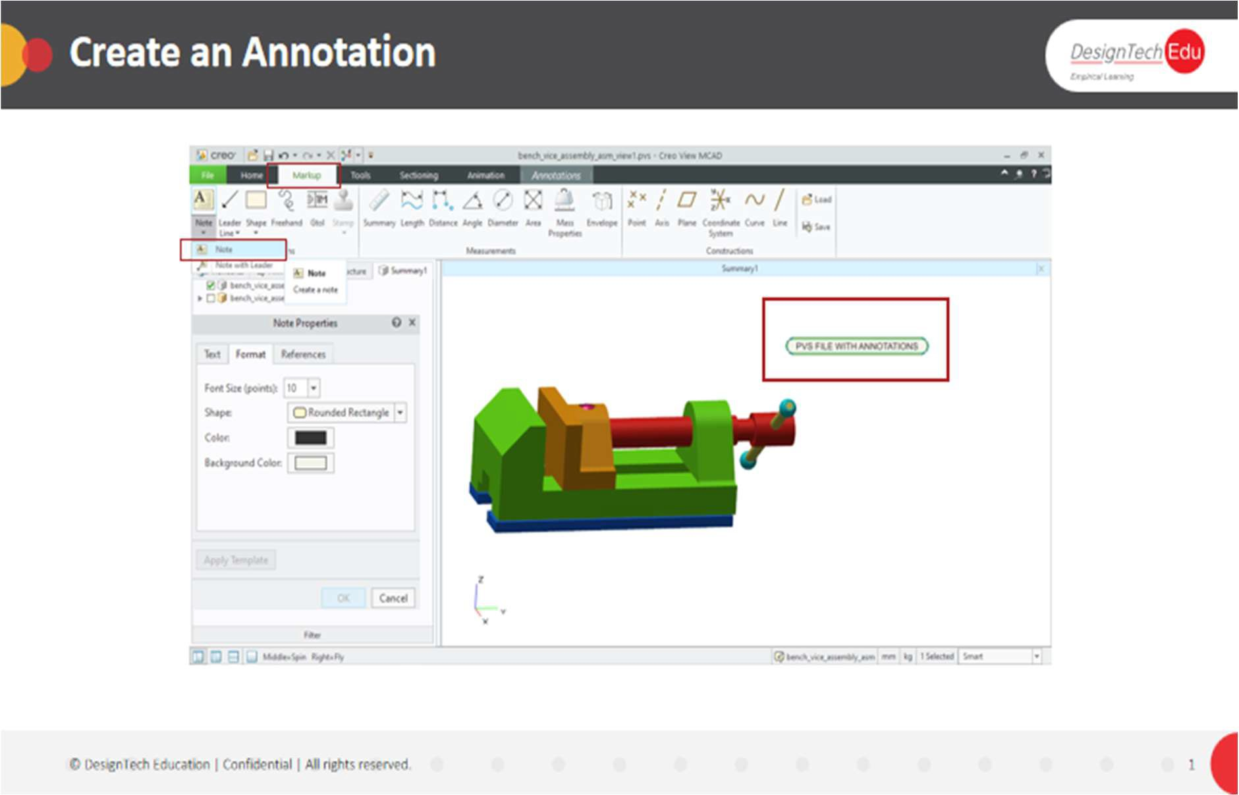

1. On the ribbon, click **Markup**, and then click an annotation type. To select a subtype, click the arrow under the annotation type. The pointer becomes an annotation pointer.
2. Place the annotation using the corresponding placement method. When you create an annotation that includes a note, the **Note** dialog box opens.
3. For note anotations, type the note and select the **Font Size**, **Font Color**, and **Background Color**, and then click **OK**.
4. To connect an annotation to another item, draw a leader line with vertices on the items to connect.
5. Click **Apply Template** to apply an annotation template to the note.

|  |  |
| --- | --- |
| **Type** | **Placement in the Graphics Area** |
| **Note** | Select a placement point. |
| **Note with Leader** | * Select the position of the head of the leader, and then drag to the point where you want to place the note. * Click once to set the position of the start of the leader, and then a second time to set the position of the note. |
| **Leader Line** | * Select the position of the head of the leader, and then drag to the point where you want to place the tail. * Click once to set the position of the head of the leader, and then a second time to set the position of the tail.   When you create a leader line with jogs, click once to place each jog and double-click to finish creating the line. |
| **Shape** | Rectangles and ellipses—Click and drag the shape to the desired size.  Freehand polygons—Click once to create each corner of the polygon and double-click to finish creating it. |
| **Freehand** | Click and drag to draw the shape. |

**To Hide or Show an Annotation**

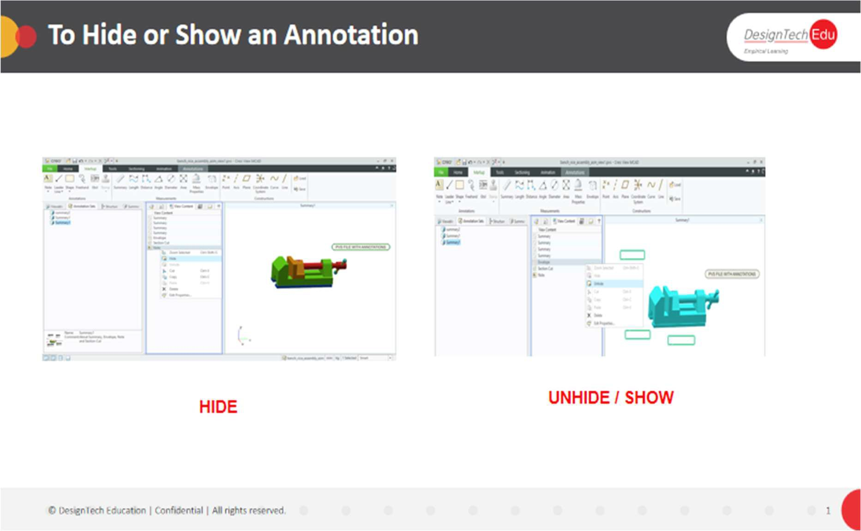

In the graphics area or the  **View Content** pane of the upper data panel, right-click the annotation and select  **Hide** or  **Unhide**. The annotation is hidden or shown.

**To Copy and Paste Annotations**

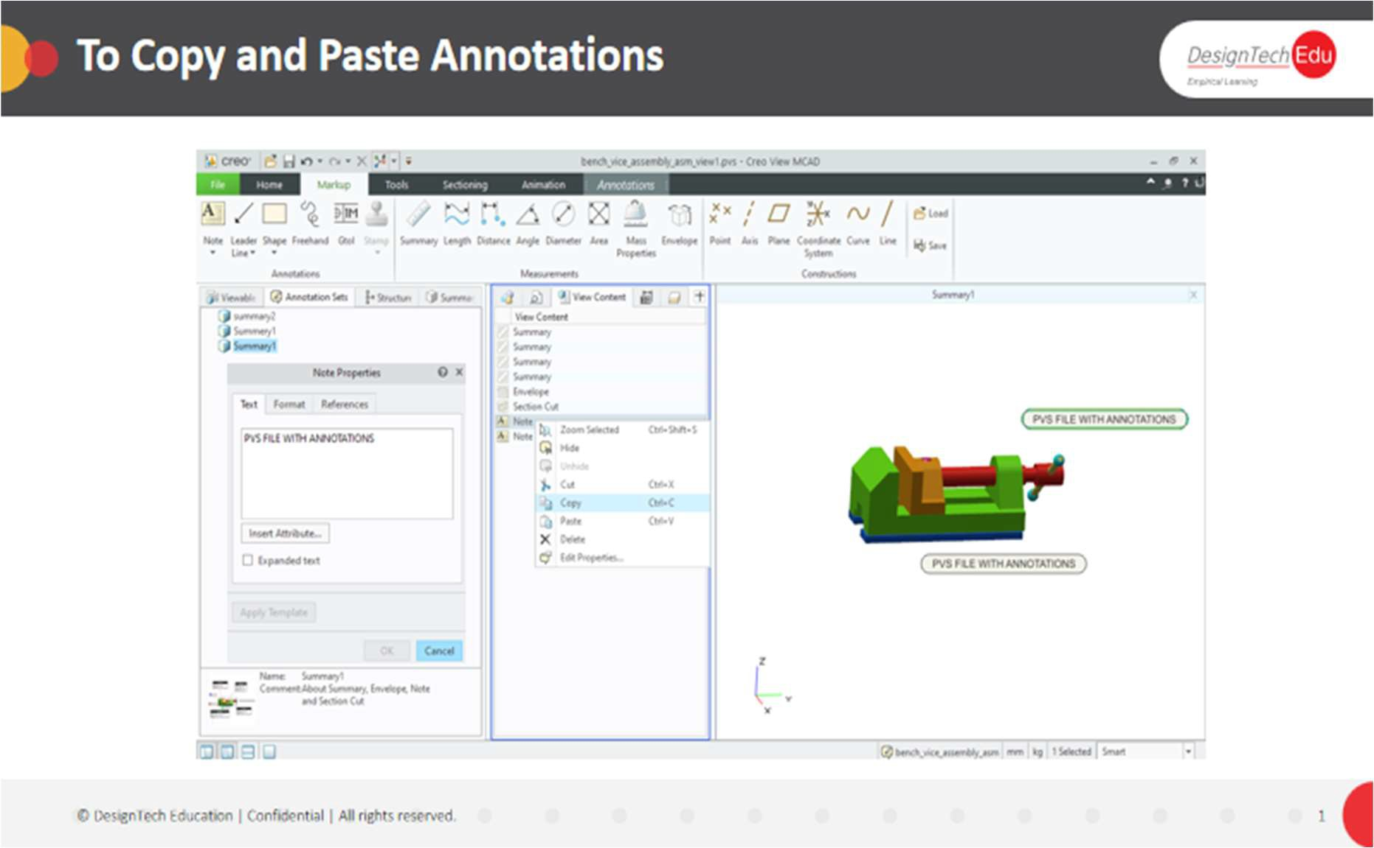

1. Select one or more annotations.
2. Right-click and select  **Copy**.
3. Right-click and select from the following options:
   * To paste the annotations in the same view, select a new location in the view and click  **Paste**.
   * To paste the annotations in another view, open another view, select the desired location and then click  **Paste**.

The annotations are placed in the new location.

**To Edit an Annotation**

You can edit one annotation, or you can edit several annotations at once. Procedures for both operations follow.

**To Edit a Single Annotation**

1. Double-click the annotation. The **Annotations** dialog box opens.
2. Make changes. The annotations are dynamically updated.
3. Click **OK**. The dialog box closes.

**To Edit Multiple Annotations of the Same or Different Types**

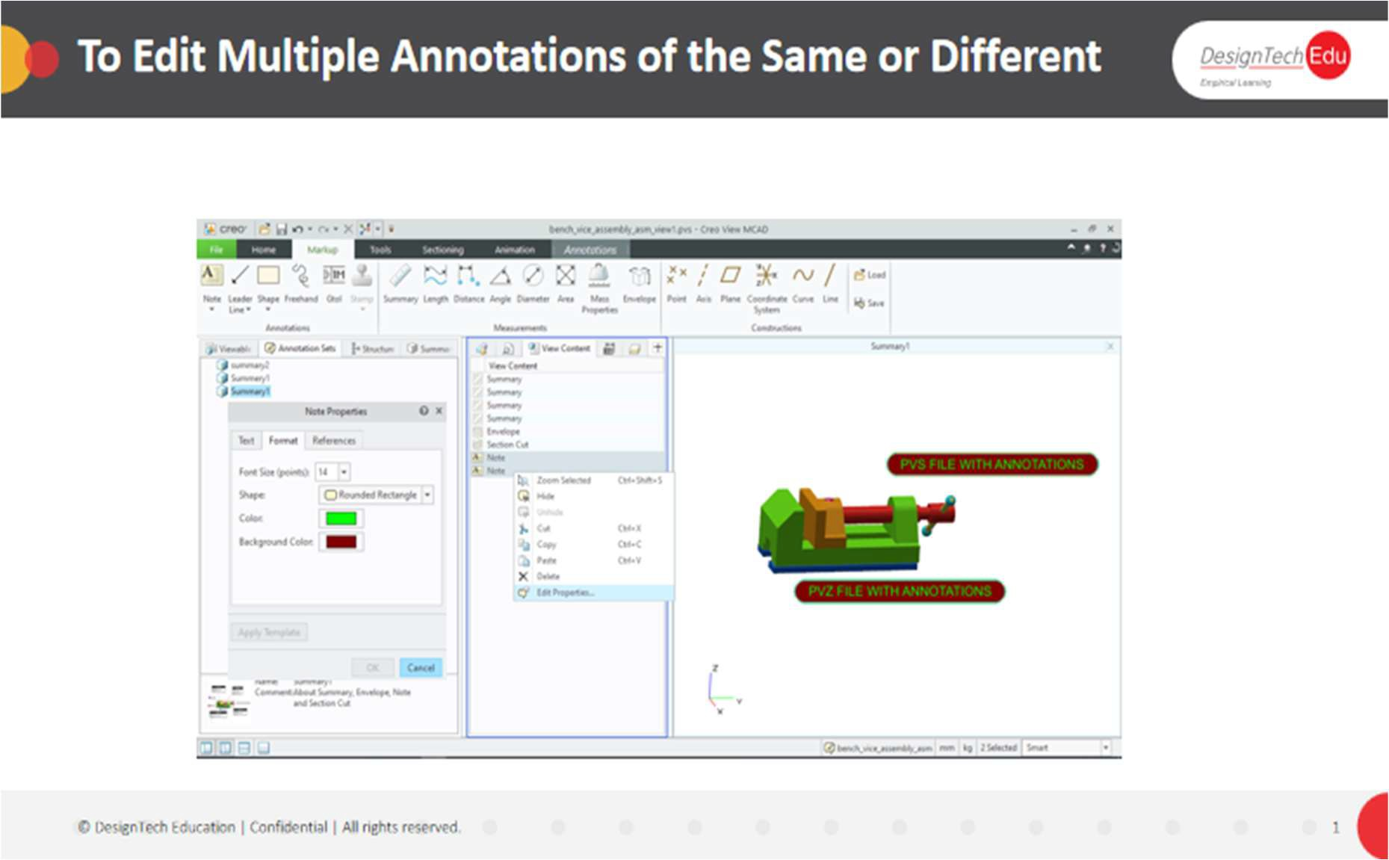

1. Select multiple annotations of the same or different types. The annotations are selected.
2. Make changes to the annotations using the **Annotations** context tab. The annotations are dynamically updated.

OR

1. Right-click and select **Edit Properties**. The **Annotations** dialog box opens.
2. Make changes to the annotations. The annotations are dynamically updated.
3. Click **OK**. The dialog box closes.

**To Delete an Annotation**

In the graphics area or the  **View Content** pane of the upper data panel, right-click the annotation and select  **Delete**. The annotation is deleted.

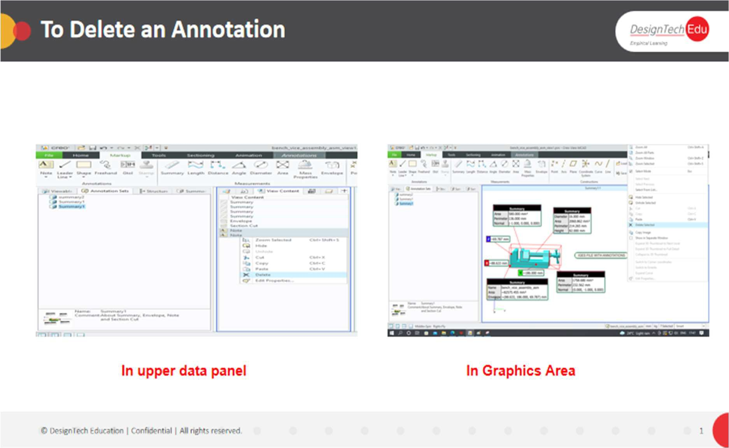

**To Delete All Annotations**

In the graphics area, right-click and select **Delete** >  **Delete All Annotations**.

**About Sequences**

**CHAPTER 5 - SEQUENCES**

A sequence is a series of illustrated, animated steps. For example, a disassembly procedure for a motor. A view can contain one sequence. In Creo View, you can view sequences created in Creo Illustrate. Play the sequence forwards or backwards. You can print one or more of the steps, each on a separate page. Each step in a sequence can have these features:

* Animated 3D graphics
* Annotations and symbols with associated tags
* Title and description text
* Statistics, such as time and cost
* Acknowledgement on or off

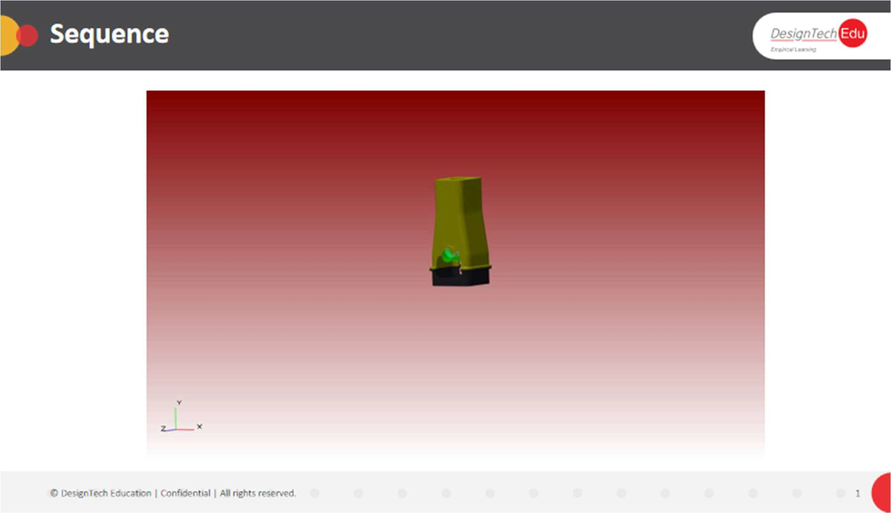

**To Play a Sequence**

The completion of one or more steps can require a confirmation. The playback stops, and the **Acknowledgment** dialog box opens with a message. To continue playing, click **Replay**, **Continue**, or **Stop**.

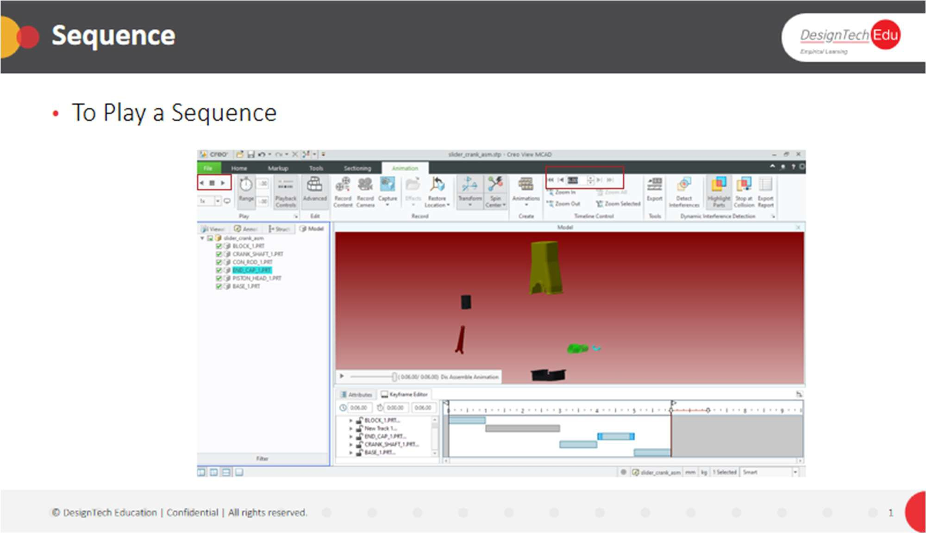

The general steps for playing a sequence follow:

1. In an open figure with a sequence, click **Home** > . The sequence plays.
2. To control the playback, click any of these buttons:

◦ 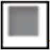—Stops the playback

◦ —Shows the next step

◦ —Shows the previous step

◦ —Returns to the beginning of the sequence

1. To play the sequence in a loop, in the box next to **Loop**, select a number of repeats.

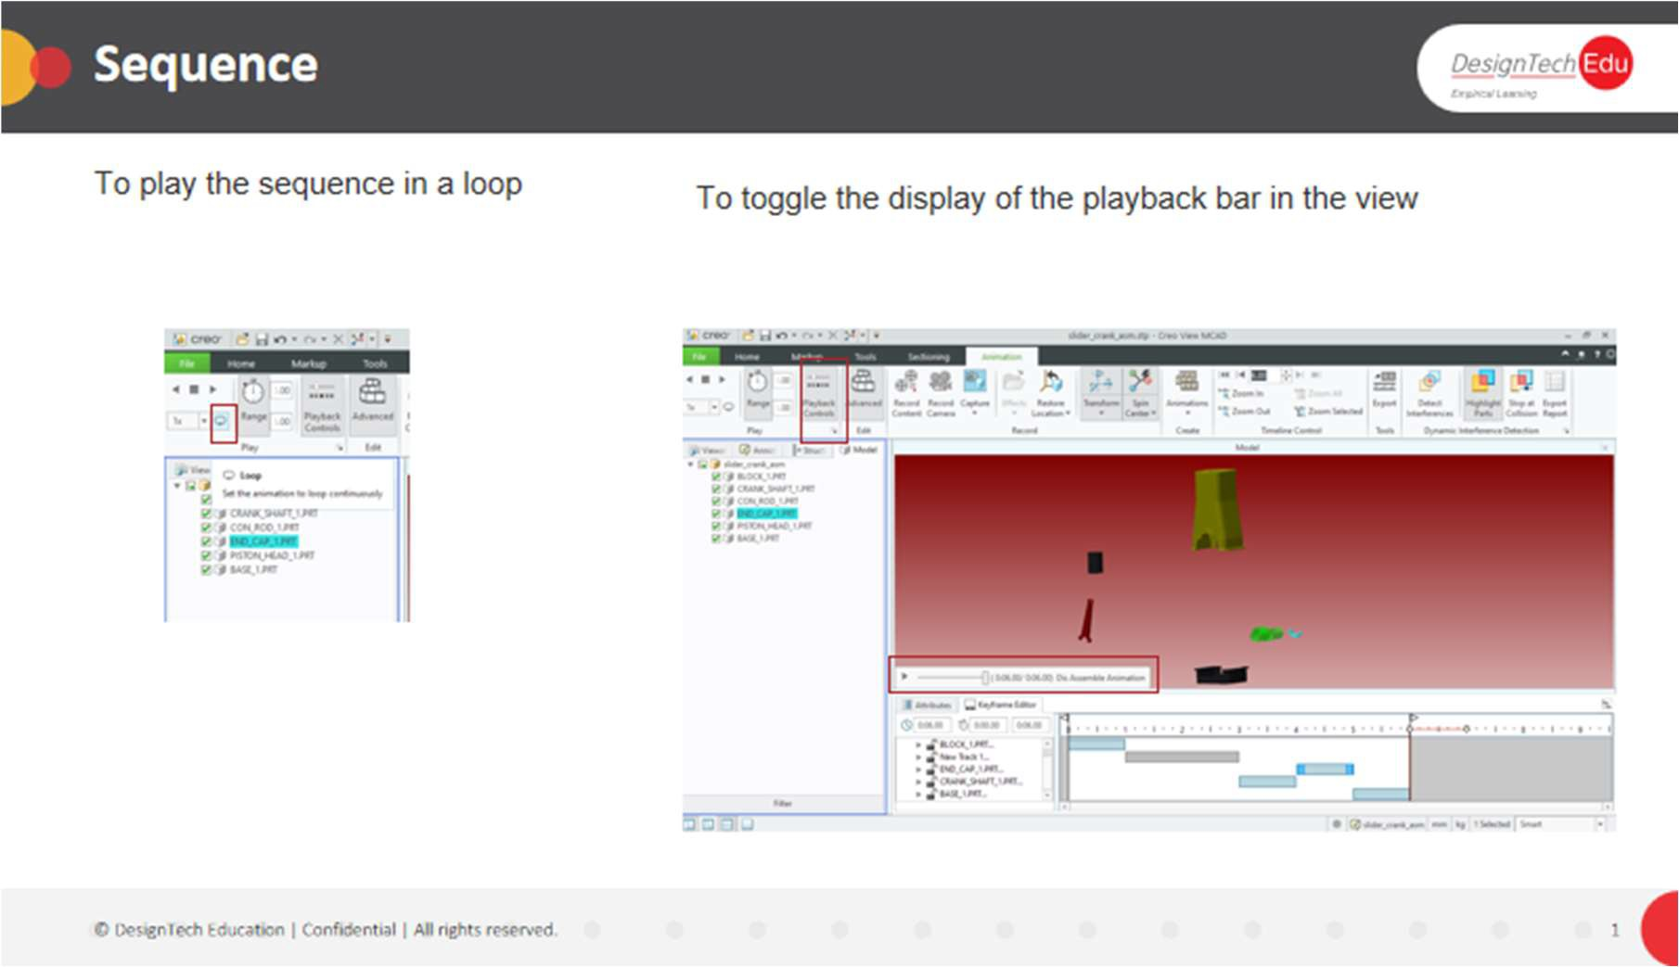

4. To toggle the display of the playback bar in the view, click **Home** >

**Playback Controls**.

**To Set the Length of a Pause**

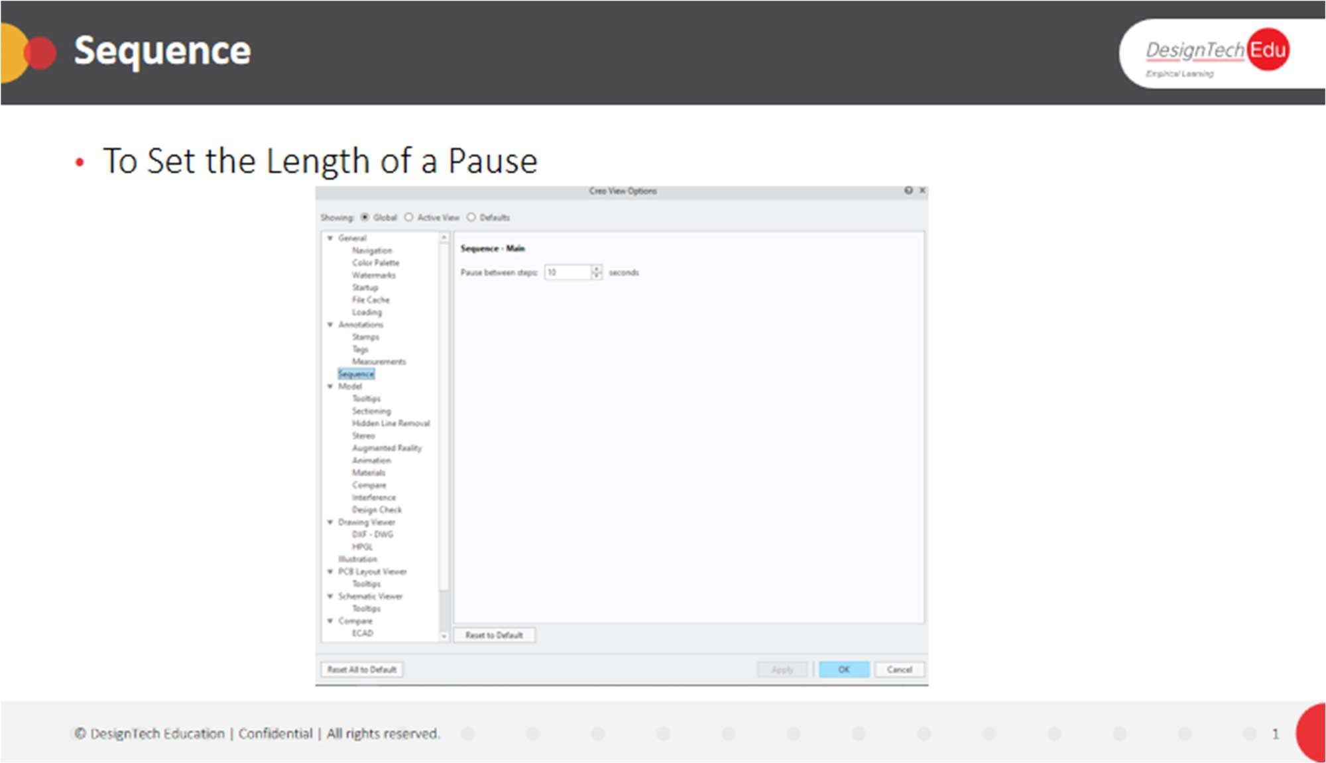

1. Click **File** > **Options**. The Creo View Options dialog box opens.
2. Next to **Showing**, select **Global**.
3. On the left, select **Sequence**. The **Sequence-Main** options open.
4. Next to **Pause between steps**, set the time interval between the sequence steps.
5. Click **OK**.

**To Add, Edit, or Delete Materials**

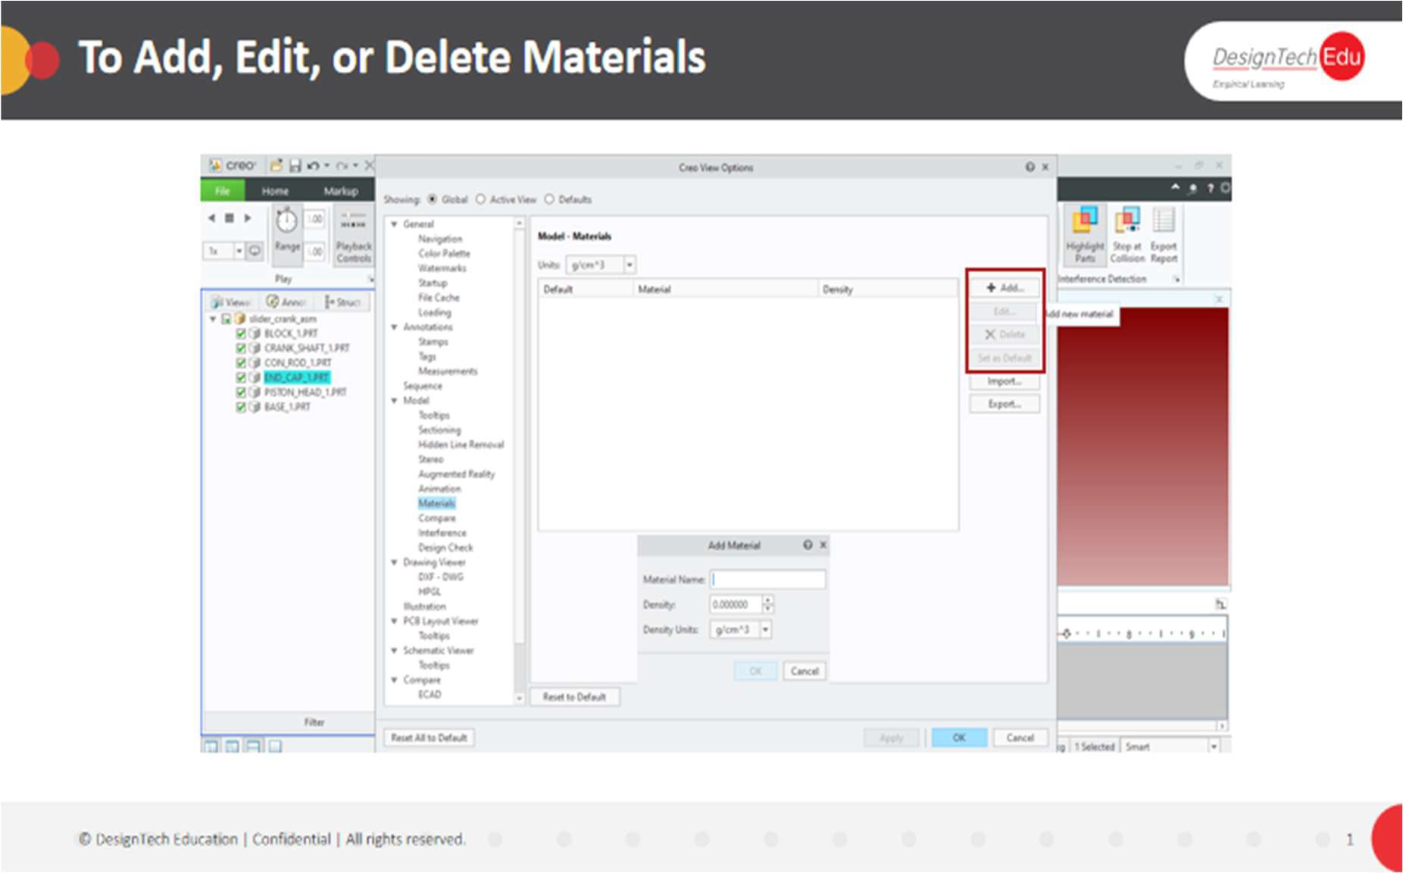

1. Click **File** > **Options**. The **Creo View Options** dialog box opens.
2. In the **Showing** box, select **Global**.
3. On the left, under **Model**, select **Materials**. The **Model**-**Materials** options open on the right.
4. Click **Add** or select a material and click **Edit**. A dialog box opens.
5. In the boxes, type or select values for the properties:
   * **Material Name**
   * **Density**
   * **Density Units**
6. Click **OK**. The material is added or its properties are updated in the **Materials** list.
7. To delete a material, select it and click **Delete**.
8. Click **OK**. The **Delete Material** dialog box opens.
9. Click **OK**. The material is deleted from the list.

**To Set the Default Material**

1. Click **File** > **Options**.

The **Creo View Options** dialog box opens.

1. Next to **Showing**, select **Global**.
2. On the left, under **Model**, select **Materials**. The **Model**-**Materials** options open on the right.
3. Under **Materials**, select a material, and then click **Set as Default**. **To Set Model-Materials Options**

In the **Creo View Options** dialog box under **Model**-**Materials**, the options relate to the following tasks:

**To Import a List of Materials**

1. Click **File** > **Options**.

The **Creo View Options** dialog box opens.

1. Next to **Showing**, select **Global**.
2. On the left, under **Model**, select **Materials**. The **Model**-**Materials** options open.
3. Click **Import**. The **Import Material** dialog box opens.
4. Browse to the folder with the list of materials, and select the file.
5. Click **Load**.
6. Click **Yes** to overwrite the current list of materials. The list is imported.

**To Export a List of Materials**

1. With a list of materials open in the **Model**-**Materials** page of the **Creo View Options** dialog box, click **Export**.

The **Export Material** dialog box opens.

1. Browse to a folder for the report on materials.
2. In the **File name** box, accept the default name or type a new one.
3. Click **Save**. The report is exported.

**About a Bill of Materials**

In Creo View, you can generate a Bill of Materials (BOM) for an MCAD structure or an ECAD design. Use the 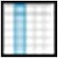 **Column Chooser** in the 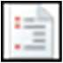 **Bill Of Materials** tool to select the data to include in the report. In the **Column Chooser**, you can also set the order of the columns.

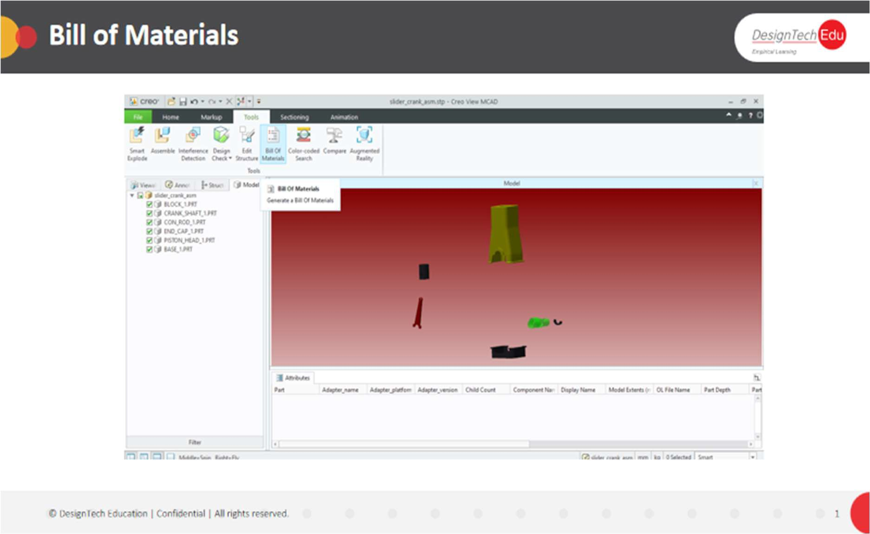

Select the columns to appear by default in the **Creo View Options** dialog box.

When you generate a BOM, a 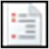 **Bill Of Materials** pane opens in the lower data panel. The information you select to include is displayed in this pane in columns. You can sort each column

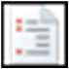by clicking the column heading. When you select an item in the **Bill Of Materials** pane, it is automatically selected in the graphics area and vice versa.

**About an MCAD Bill of Materials**

You can generate an MCAD BOM for all or part of a structure. Use the 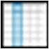 **Column Chooser** to configure and automatically update a BOM before or after it is generated.

You can have one BOM for each view of the structure. Select one of these types to generate:

* **Parts only**
* **Assemblies only**
* **Top-level components only**
* **All, Flat**
* **All, Hierarchical**

You can export the BOM as a CSV file (*.csv) or as a Web page (*.htm or *.html). You can also use the shortcut menu to copy one or more of the rows to the clipboard.

**To Generate an MCAD Bill of Materials**

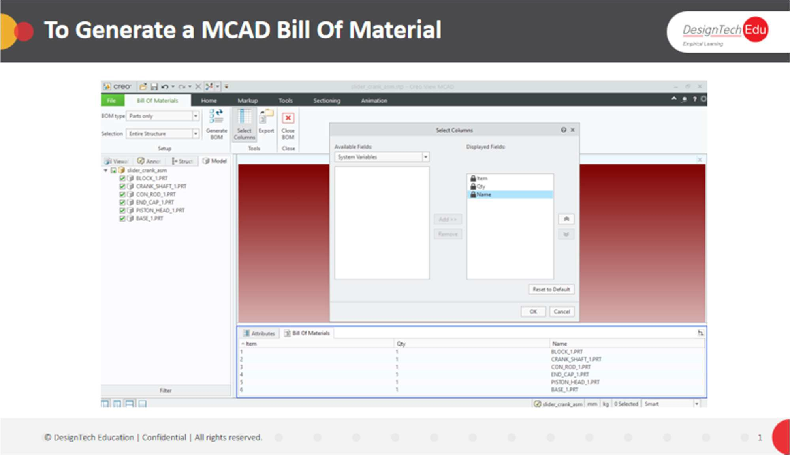

1. With a structure open, click **Tools** > 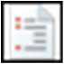 **Bill Of Materials**. The **Bill Of Materials** tab of the ribbon opens.
2. Select a **BOM type** from the box.
3. Specify the inventory for the BOM in the **Selection** box.
4. To select the information to include in the BOM, click 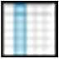 **Select Columns**. The **Select Columns** dialog box opens.
5. Click **Bill Of Materials** > 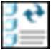 **Generate BOM**. The bill of materials is created.

**To Set Bill of Materials Options**

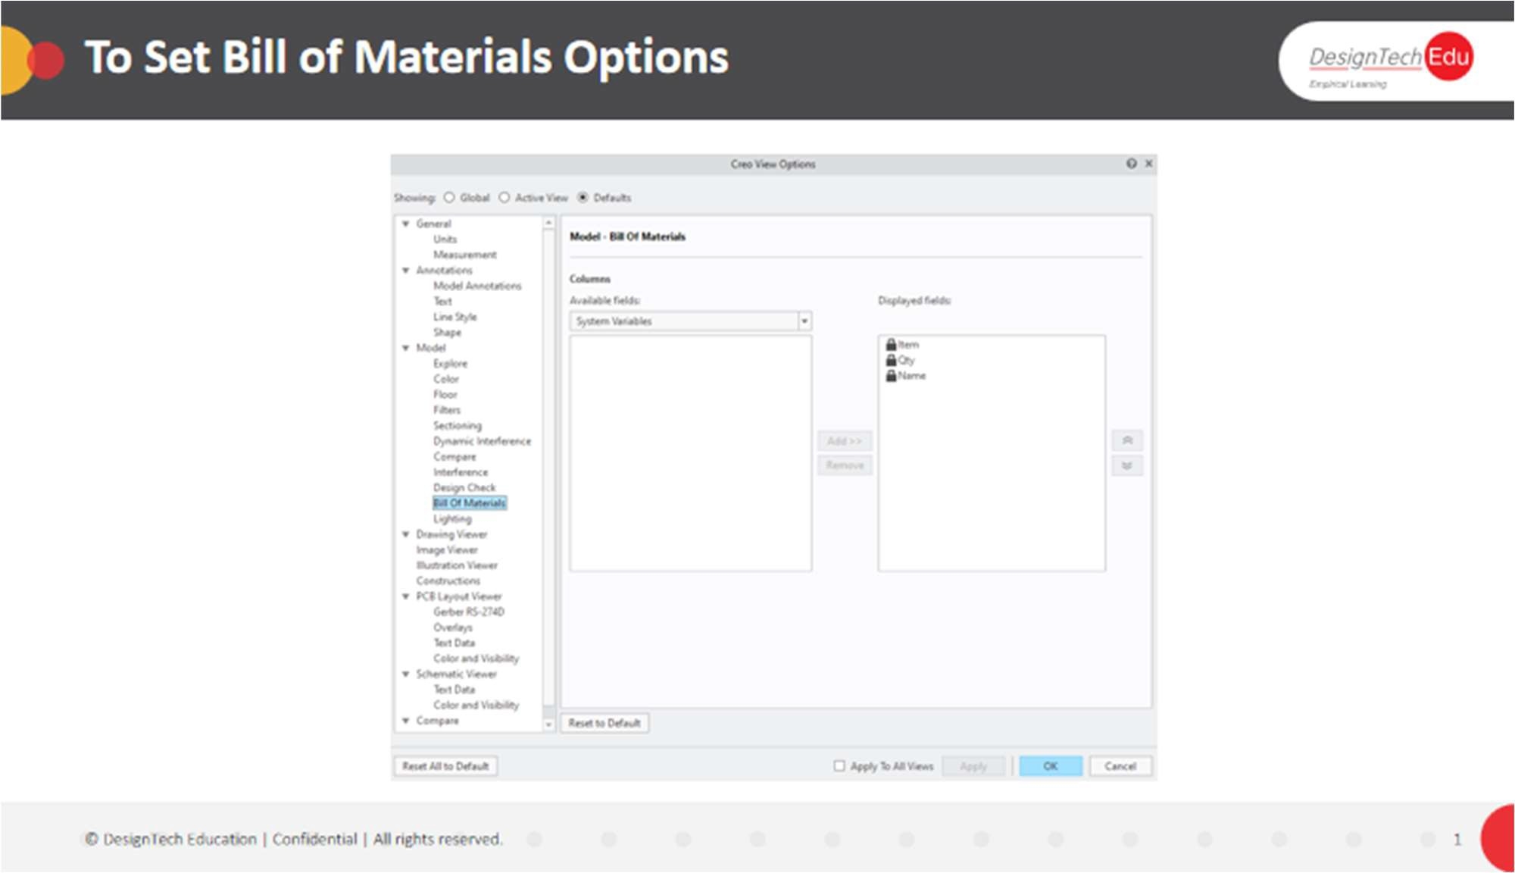

1. Click **File** > **Options**.

The **Creo View Options** dialog box opens.

1. Next to **Showing**, select **Global** or **Defaults**.
2. On the left, for MCAD select **Model** > **Bill Of Materials**. For ECAD, select **PCB Layout Viewer** > **Bill of Materials**. On the right, the options open.
3. To add one or more columns to the list of defaults, select them in the **Available Fields** list, and then click **Add**. The columns are added to the **Displayed Fields** list.
4. To remove one or more columns from the list of defaults, select them in the list under **Displayed Fields** and click **Remove**. The columns are removed from the **Displayed Fields** list.
5. To reorder the columns, select a column in the **Displayed Fields** list, and then click 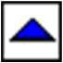 or 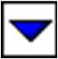 to change its position.
6. Click **OK**. The options are saved.

**CHAPTER 6 - REPORTS AND FILE FORMAT**

# About a Design Data Report

In Creo View, you can create these types of ECAD design report:

* **Object Specific**—Includes all available information about each component of the selected type.
* **Design Statistics**—Provides information about the creation of the design along with the number of components of each type. Create a **Design Statistics** report for the design as a whole, a group of selected objects, or a selected subcircuit.

Both report types include information on placed and unplaced components. For an **Object Specific** report, you can use the 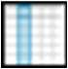 **Column Chooser** after you generate the report to select the data to include. In the **ECAD Report Column Chooser** dialog box, you can also set the order of the columns. Some columns are  locked and cannot be removed from the report using the **Column Chooser**.

When you generate a report, a  report pane opens in the lower data panel. The information you select to include is displayed in this pane in columns. Rows of pin information associated with components are not included on the report pane, but they appear in an exported report. You can sort fixed columns with single-value entries by clicking the column heading. When you select an item in the report pane, the graphics area, or the substructure pane of the primary panel, it is automatically selected in all three locations.

# About Saving Files

You can save MCAD structures, ECAD designs, and their associated viewables and annotation sets:

* **PVZ**—Includes files for all viewables and annotations.
* **PVS**—Saves the information as a directory and references the viewable and annotations files.

**To Save PVS and PVZ Files**

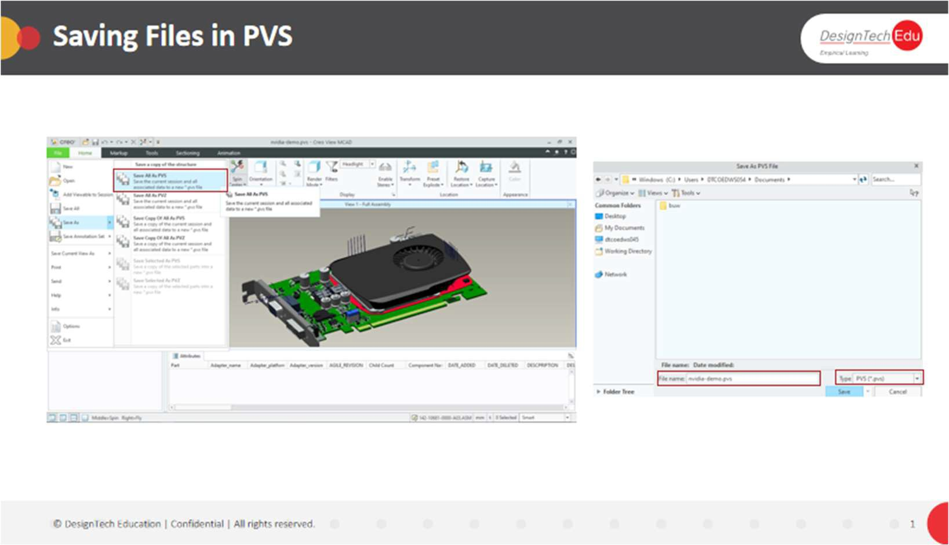

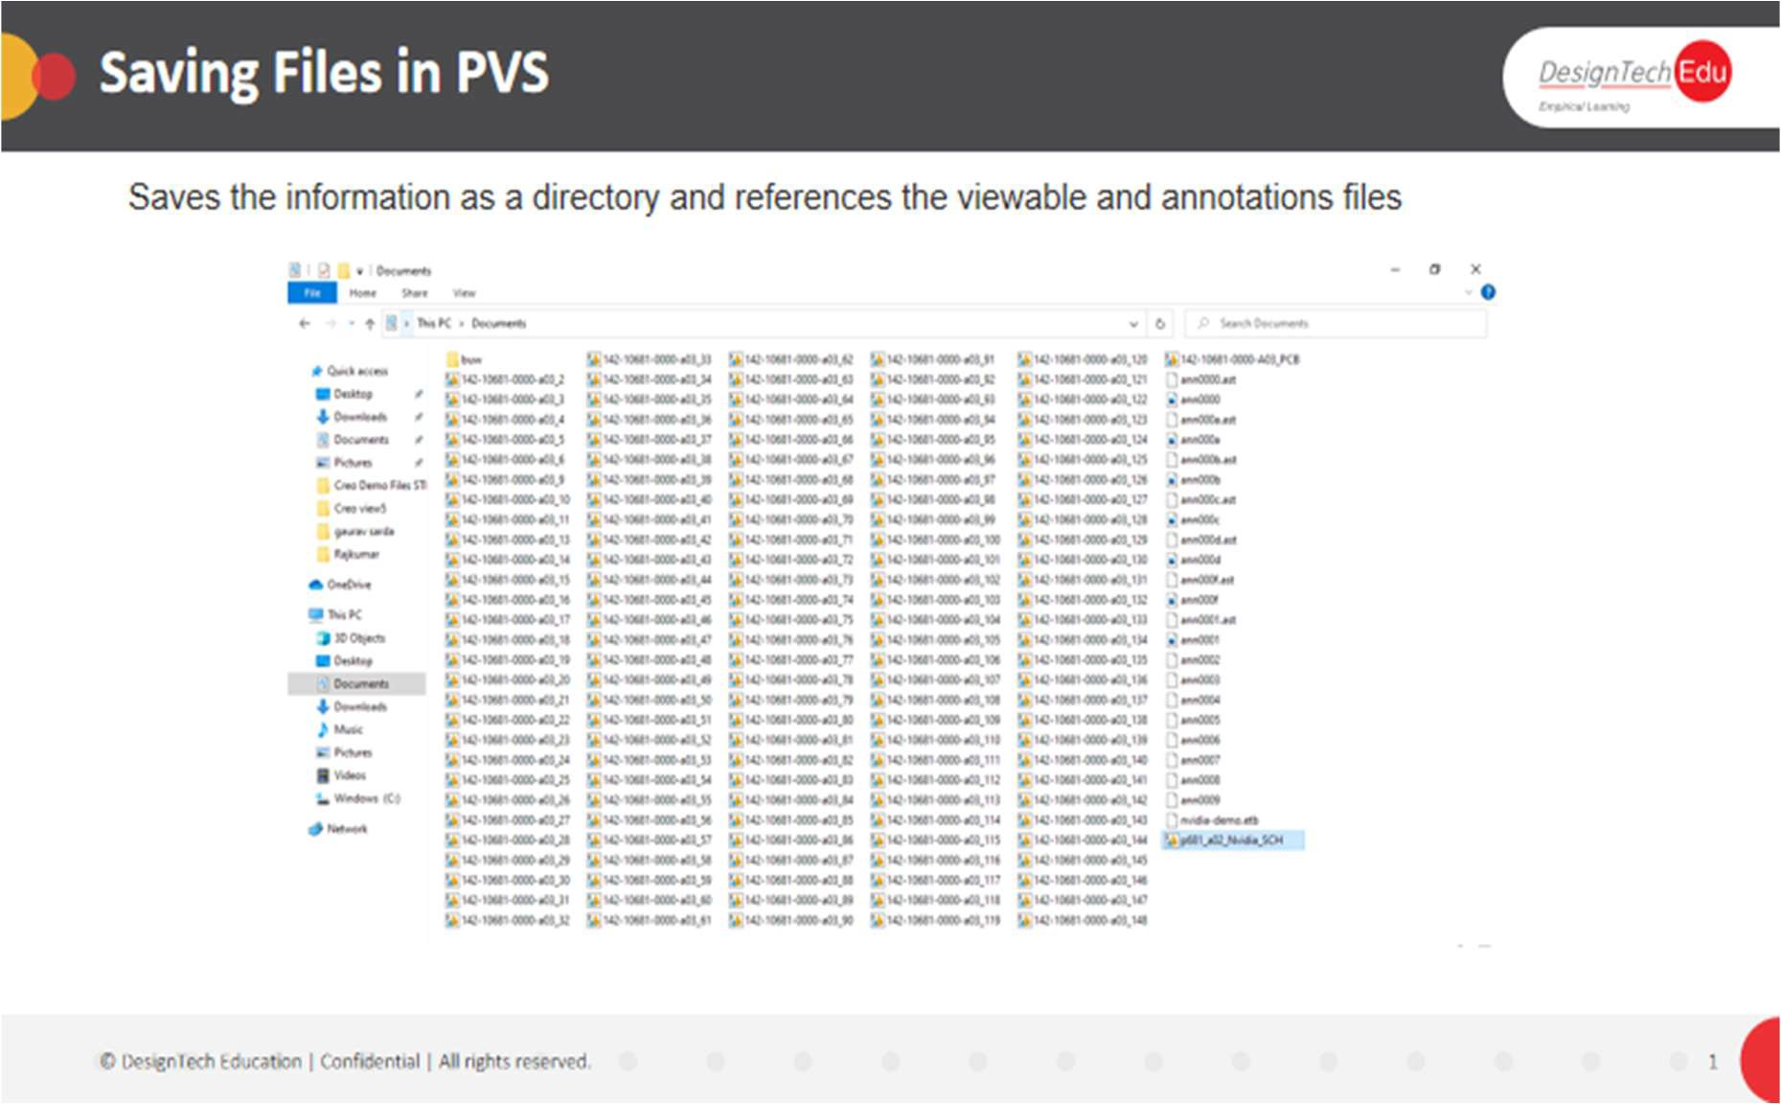

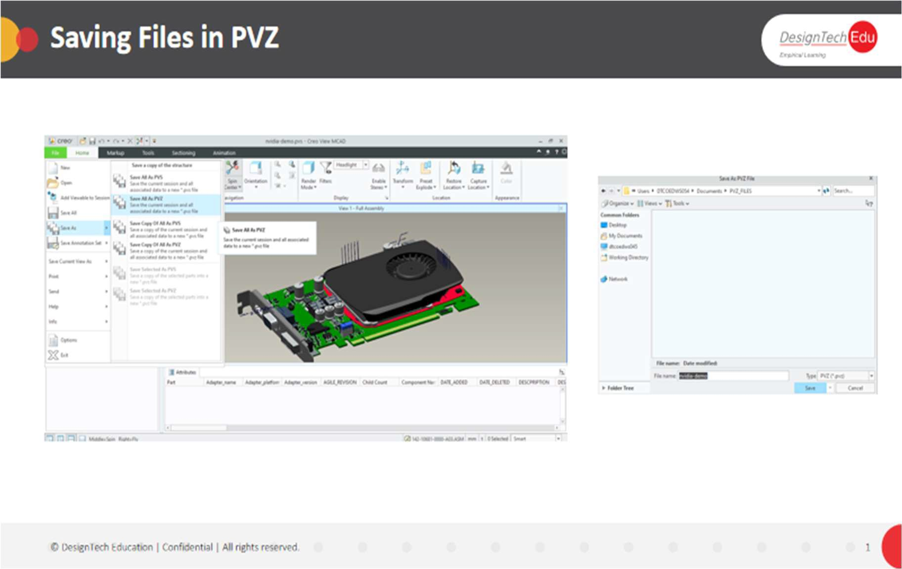

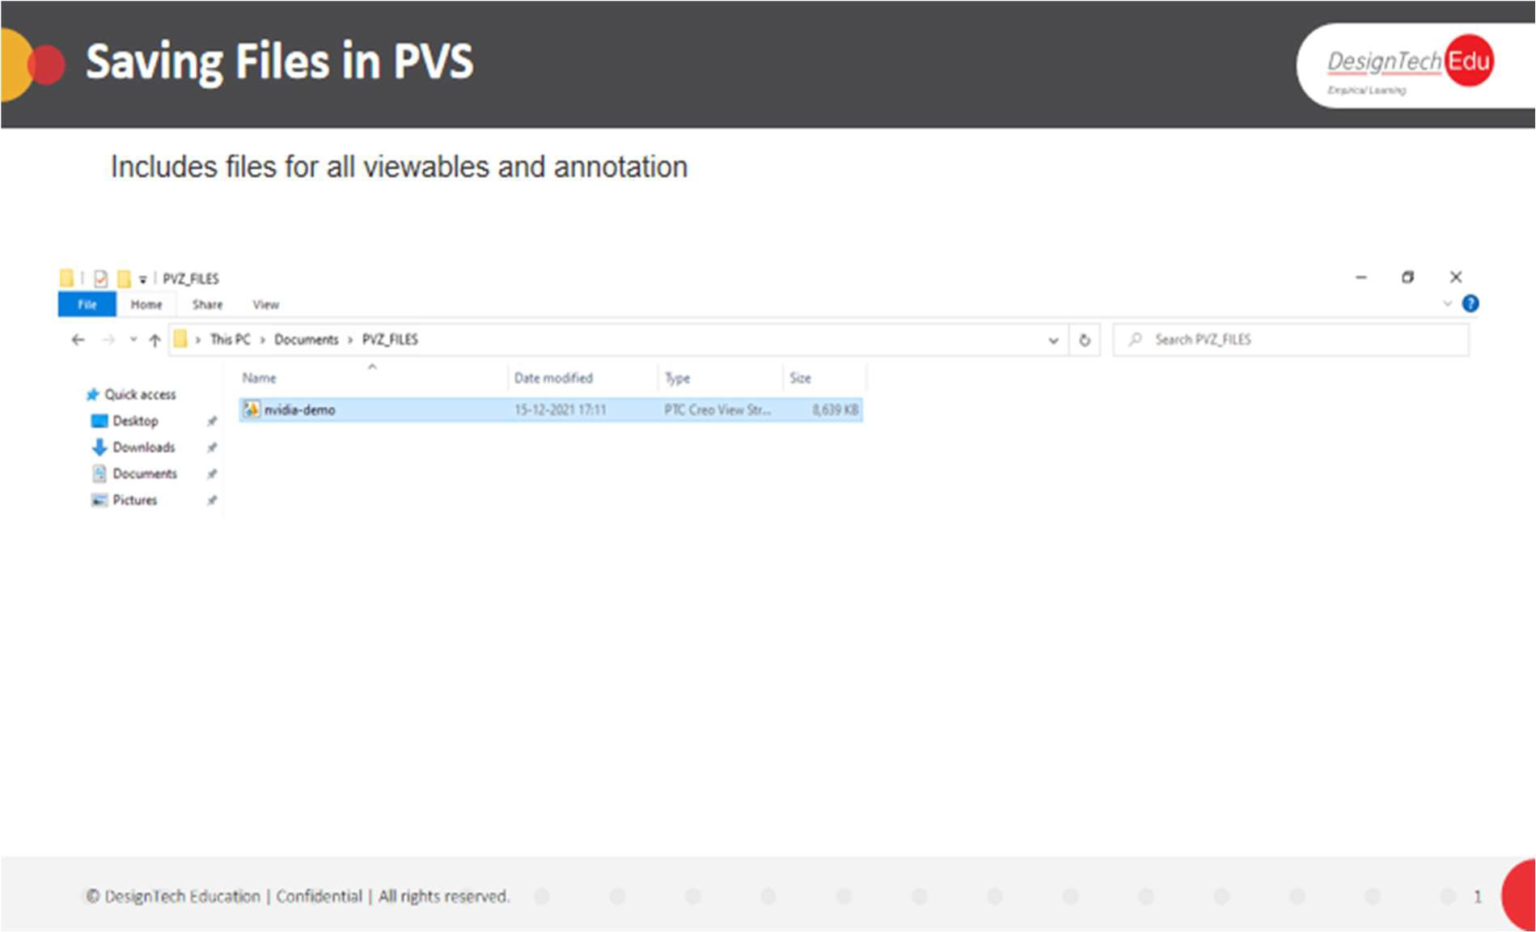

You can save Creo View PVS and PVZ model files in the following ways:

|  |  |
| --- | --- |
| **Operation** | **Procedure** |
| To save the current session and all associated data. | Select **File** > **Save All**. |
| To save the current session and all associated data to a new PVS. | 1. Select **File** > **Save As** > **Save All As PVS**. The **Save As PVS File** dialog box opens. 2. Type a name for the new file, and then click **Save**. |
| To save the current session and all associated data to a new PVS, without changing the current session. | 1. Select **File** > **Save As** > **Save Copy Of All As PVS**. The **Save Copy As PVS File** dialog box opens. 2. Type a name for the new file, and then click **Save**. |
| To save one or more selected parts in a separate file. | 1. Select one or more parts, and click **File** > **Save As** > **Save Selected As PVS**. The **Save Copy As PVS File** dialog box opens. 2. Type a name for the new file, and then click **Save**. The **Save Selected As PVS: Settings** dialog box opens. 3. Under **Include**, select any of the following items to include with the parts in the new file, and then click **Save**.    * **Attributes**    * **Structure to root**    * **Children of selected**    * **Specified file types**—The file source types of the selected nodes in the structure tree |

**To save one or more selected parts in a separate file.**

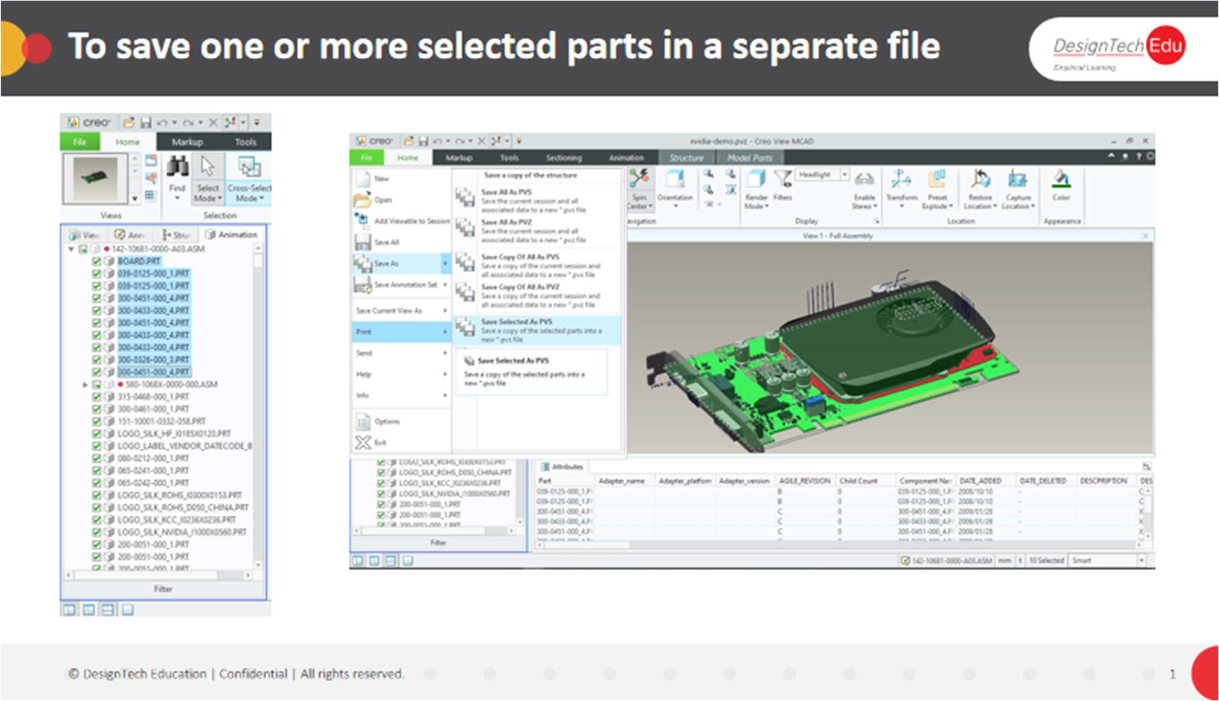

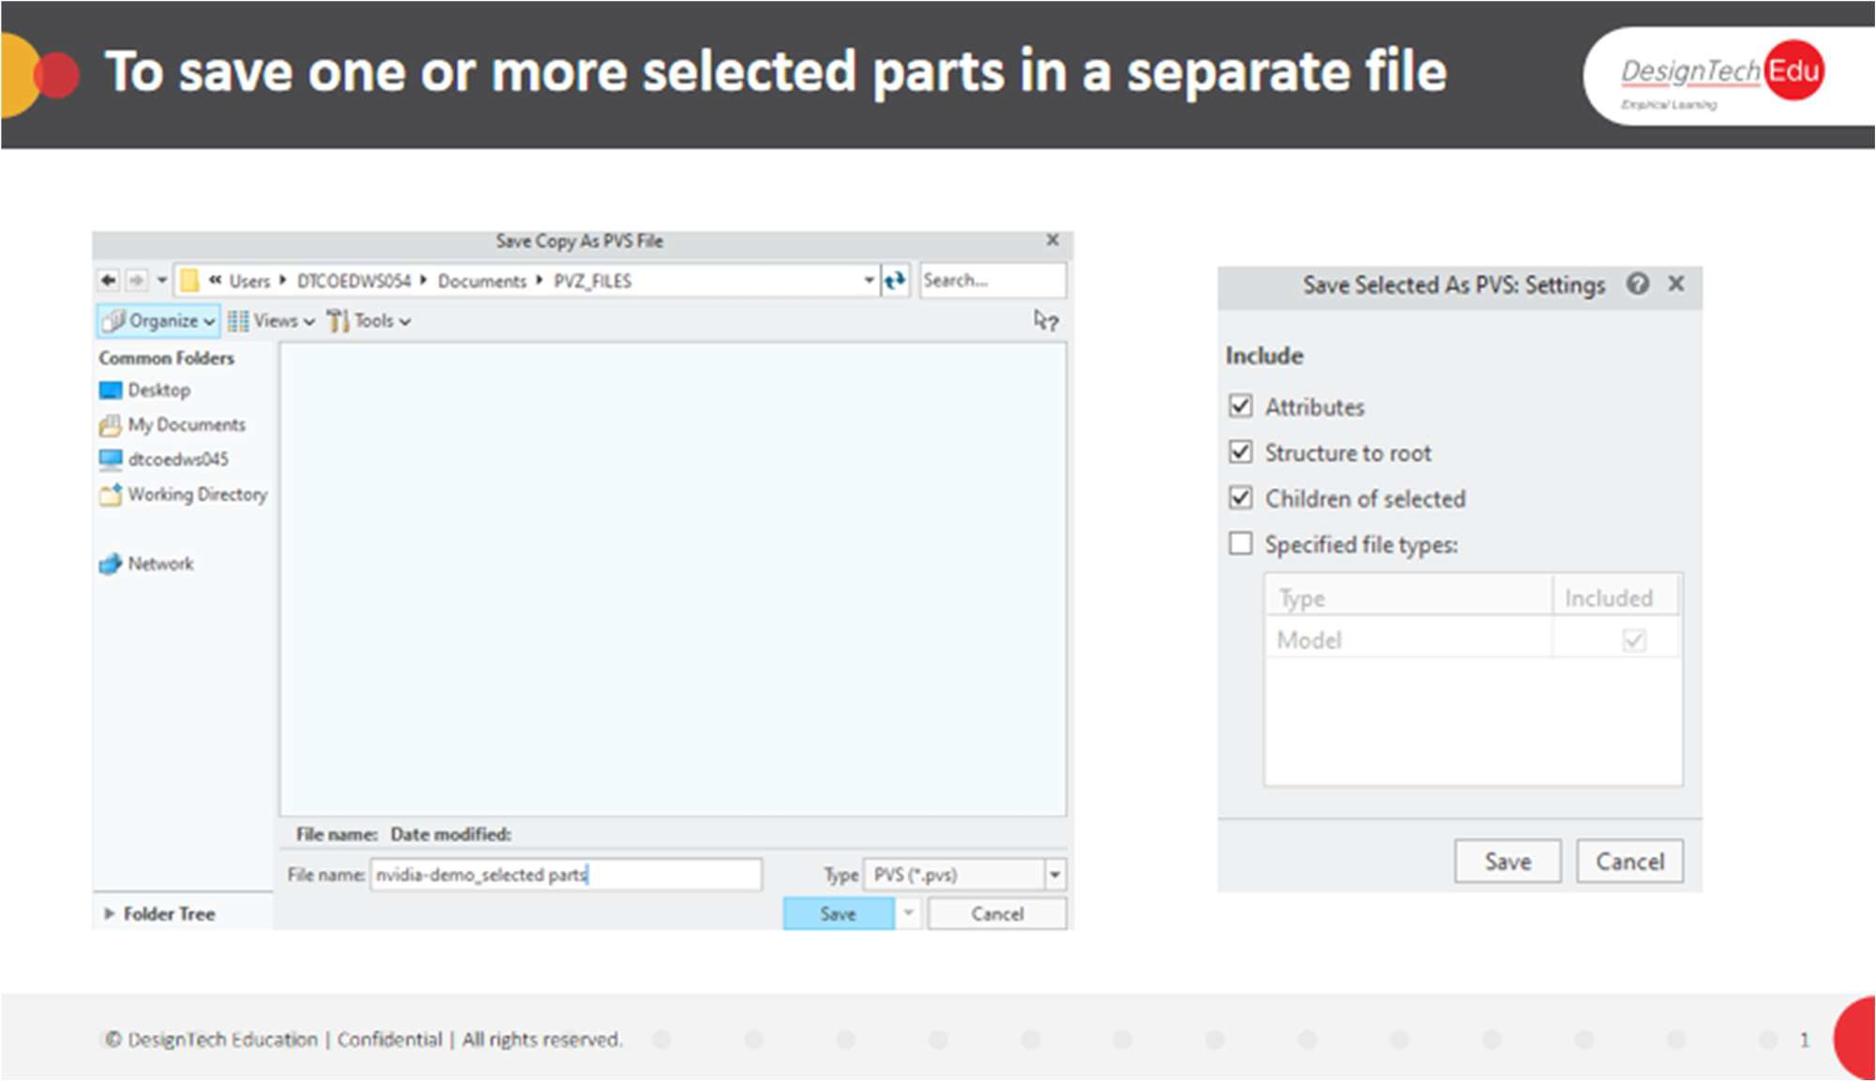

# To Save an External File Format in Creo View

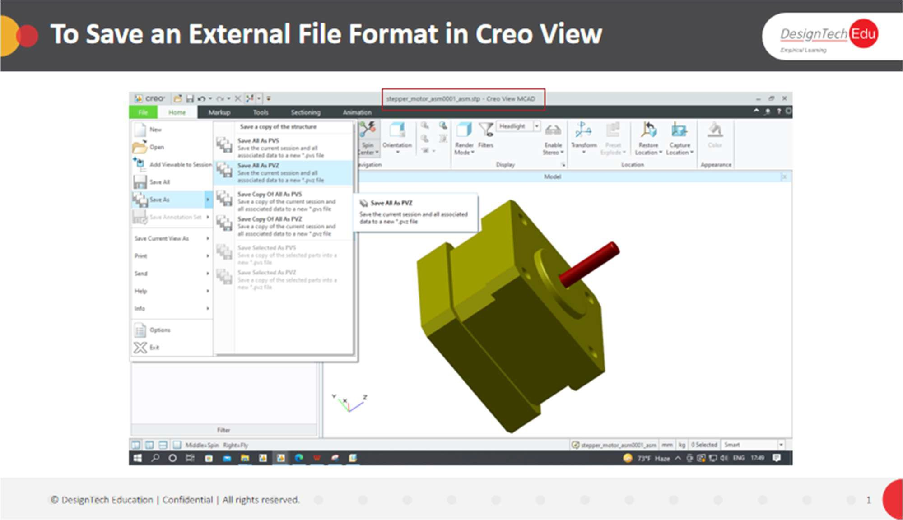

1. To overwrite the current structure, click **File** > **Save All**. The files are saved.
2. To create a new structure, click **File** > **Save As**, and then click one of these options:
   * **Save All As PVS**
   * **Save All As PVZ**
   * **Save Copy Of All As PVS**
   * **Save Copy Of All As PVZ**

The **Save As** dialog box opens. Proceed to Step 5.

1. To save an ECAD view as an EDA file, when working in Creo View, click **Save Current View As** > 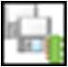 **As an EDA file**.
2. The **Save View as EDA** dialog box opens.
3. Select a location for the file.
4. In the **File name** box, accept the default file name, or type a new one.
5. Click **Save**.

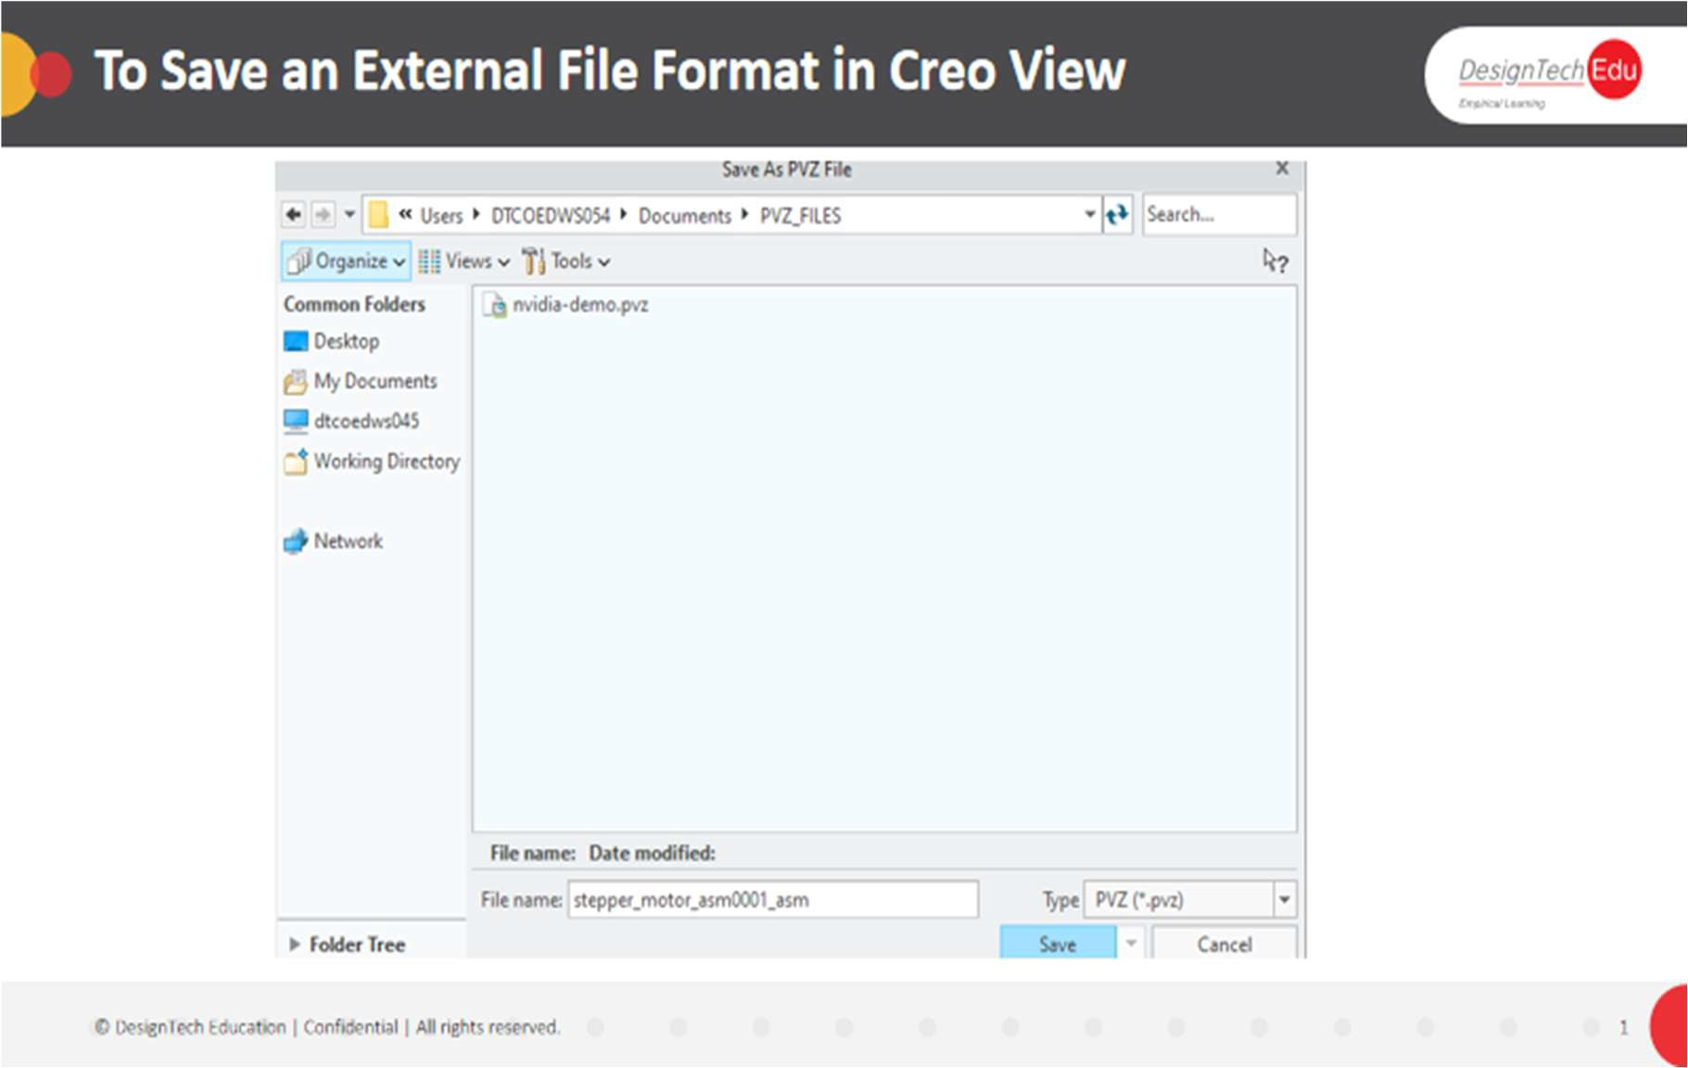

# To Generate a Design Data Report

1. Click **Tools** > **Design Data**. The **Design Data** tab of the ribbon opens.
2. In the **Report Type** box, select **Object Specific**.
3. In the **Selection** box, select the object type for the report.
4. Click **Design Data** > **Generate Report**. The report is created.

**CHAPTER 7 - CONSTRUCTION GEOMETRY**

**About Construction Geometry**

Ýou can create construction geometry and use it as a reference for a number of operations:

* Translating or rotating parts along an axis

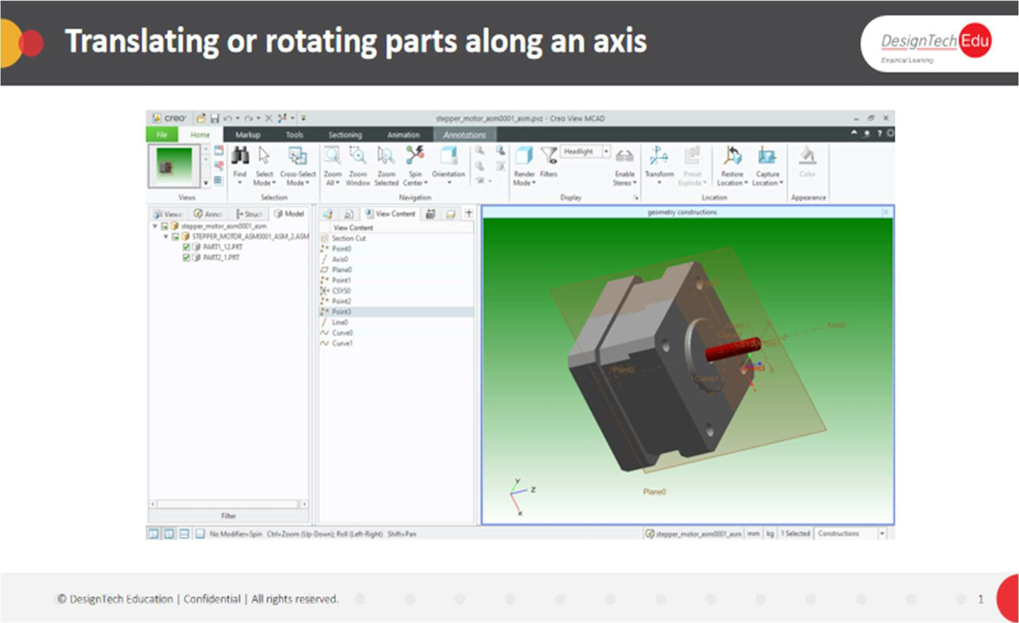

* Positioning a section plane

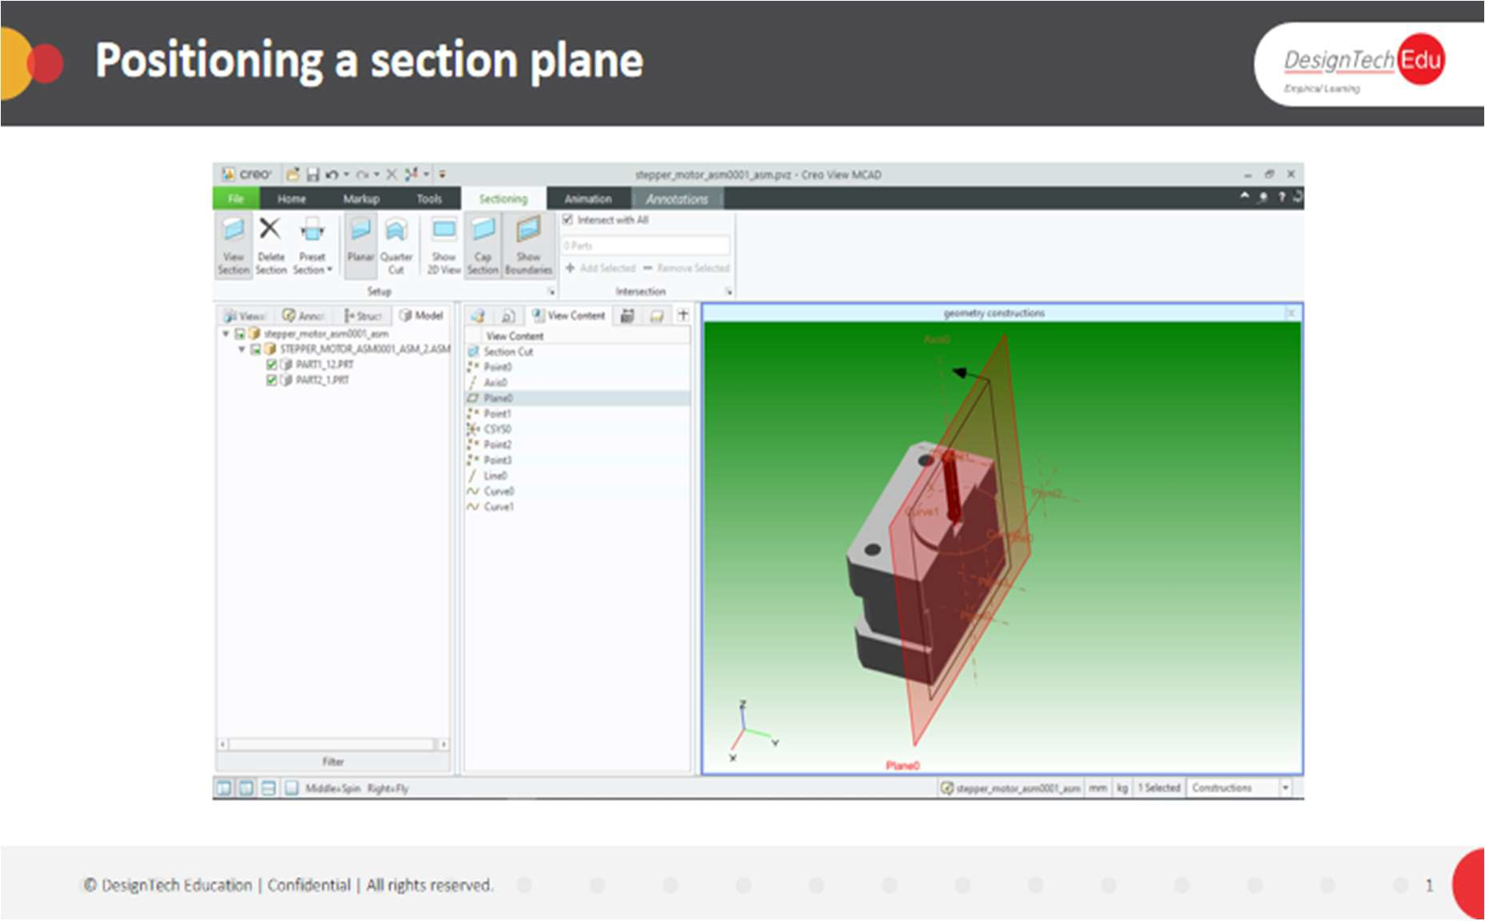

* Creating measurements

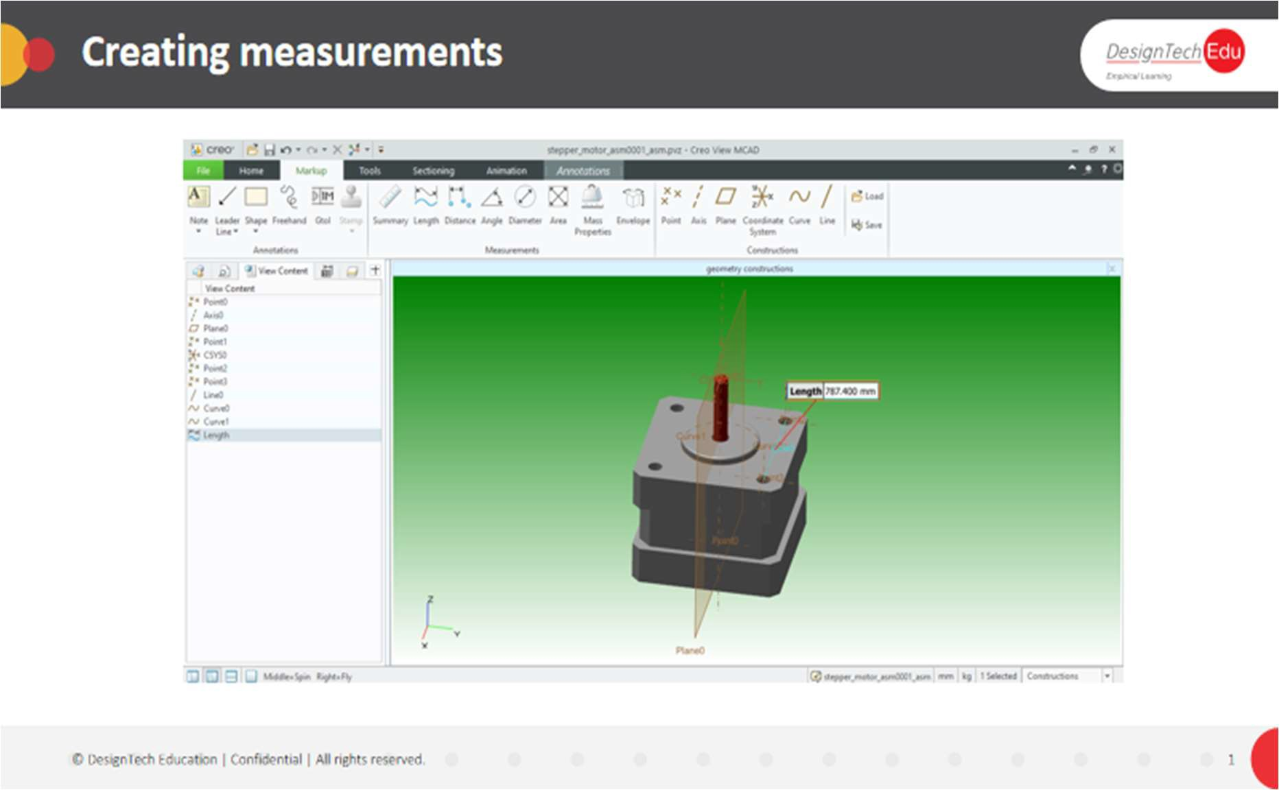

You can load and clear construction geometry and save them as annotation sets

You can hide construction geometry and use the Find command to find construction geometry in the structure. Construction geometry entities retain their size when the camera zooms in or out. You can create the following construction geometries in 2D or 3D views:

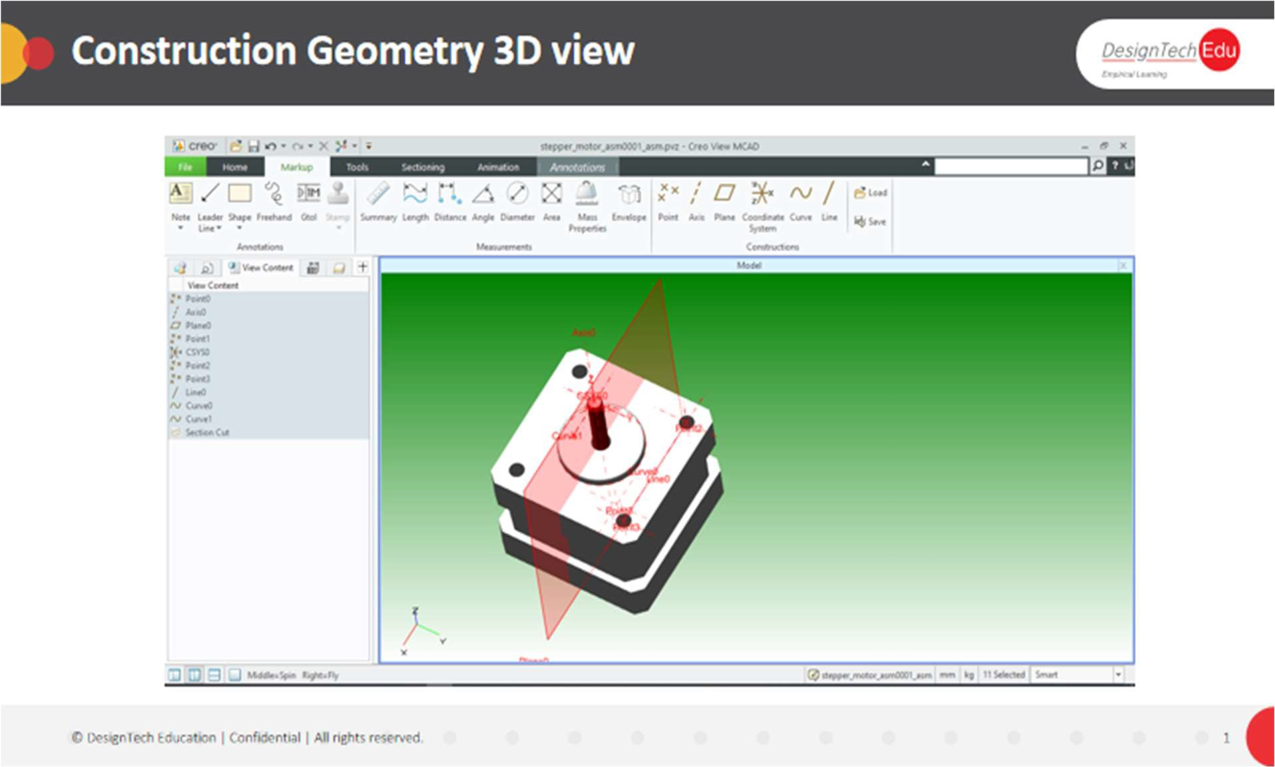

|  |  |
| --- | --- |
| View | Construction Geometry |
| 3D view | Points, axes, planes, curves, coordinate systems, and lines |
| 2D drawing view | Points, axes, and lines |

**To Create Construction Geometry**

1. On the Markup tab, select a construction type. The dialog box of the selected construction type opens.
2. In the graphics area, select a reference entity. It appears in the reference collector.
3. If Constraint options appear in the collector, select one.
4. To add another entity to the construct, click Add and then select the entity.
5. To remove a reference entity from the collector, right-click and choose Remove.
6. Click OK.

**To Create a Coordinate System**

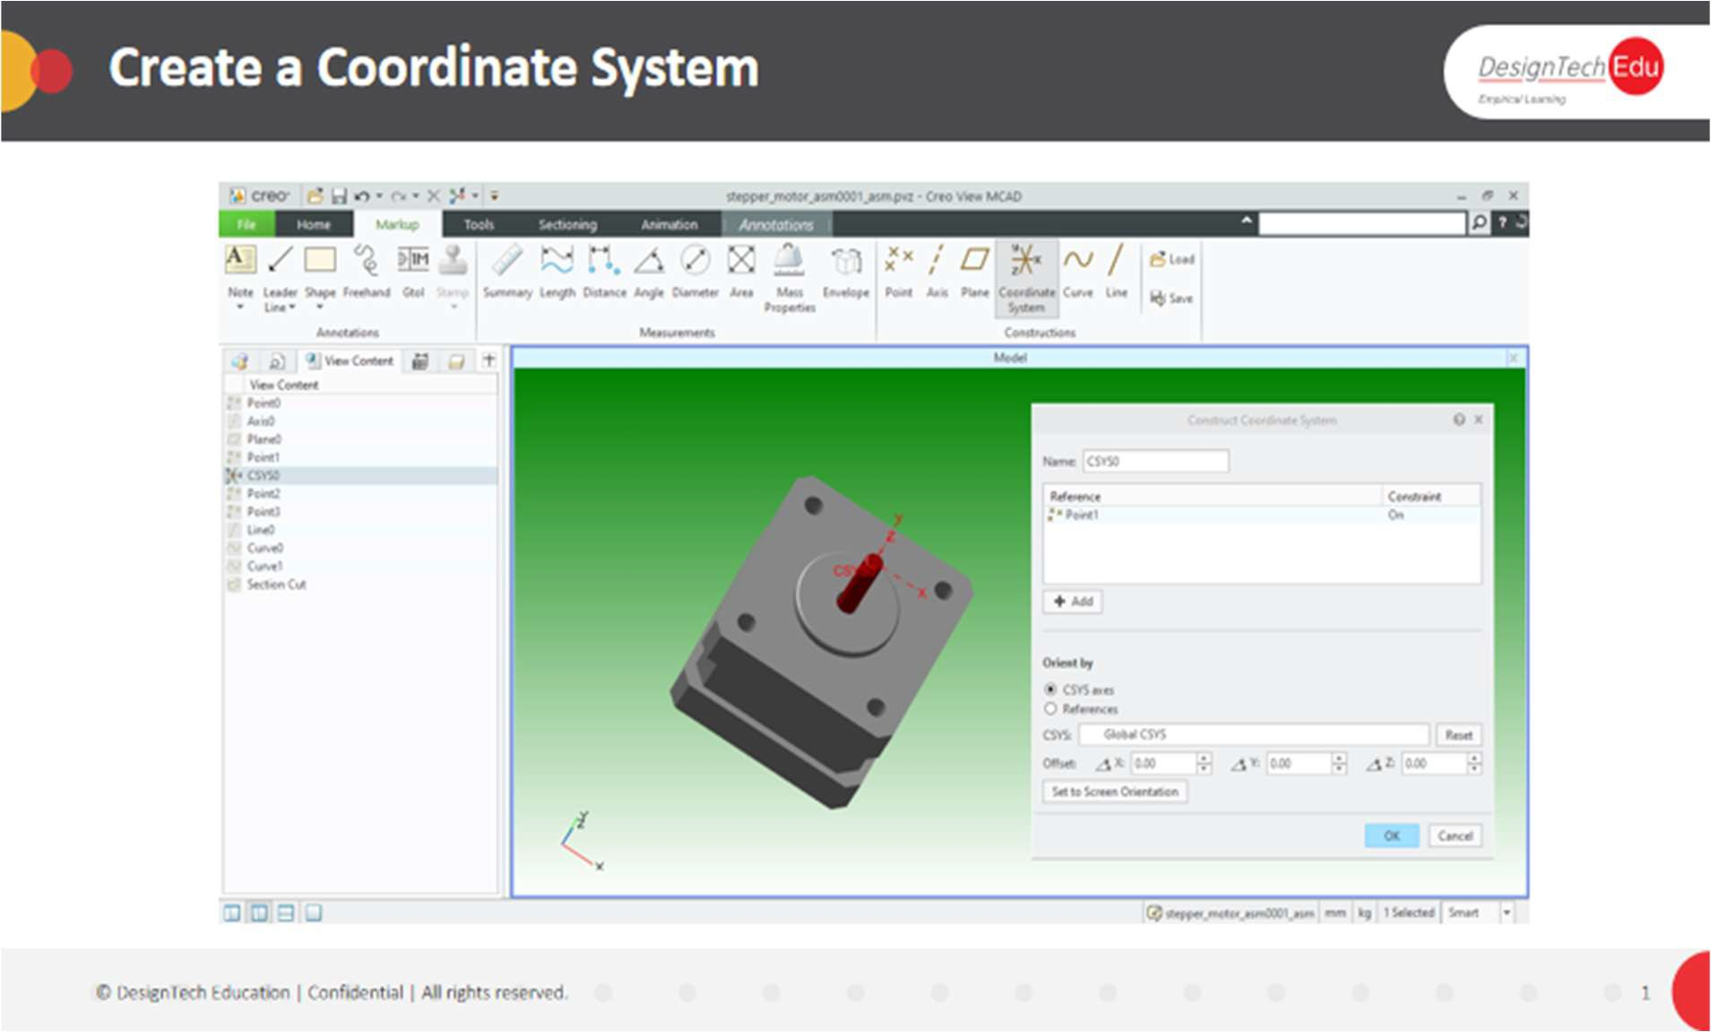

1. On the **Markup** tab, select **Coordinate System**. The **Construct Coordinate System** dialog box opens.
2. In the graphics area or the Structure Tree, select a reference for the coordinate system.
3. To change the orientation of the coordinate system by resetting its axes, select **CSYS axes**. Type the **Offset** values, and then click **Reset**. The view updates to the new coordinates.
4. To change the orientation of the coordinate system by referencing entities in the design, select **References** and then select reference entities for two of the coordinate axes.
5. Click **OK**.

**To Load Construction Geometry**

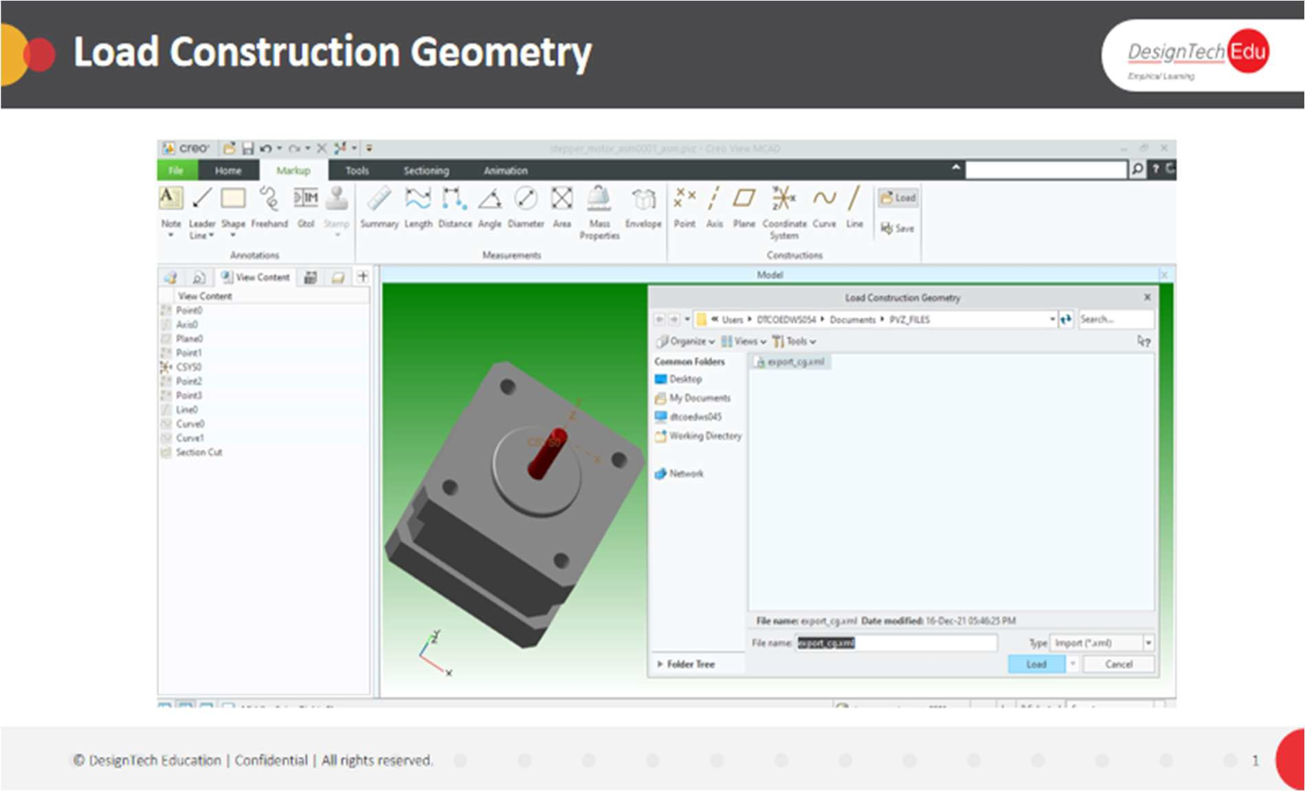

1. Click **Markup** > **Load**. The **Load Construction Geometry** dialog box opens.
2. Select an XML file and click **Load**. The geometry is loaded into the current view. To Show or Hide Construction Geometry
3. In the upper data panel click. The **View Content** pane opens, displaying symbols of all

the show and hidden construction geometry.

1. Right-click and choose **Edit Properties** to view construction geometry properties.
2. Right-click and choose **Hide** to hide geometries. Alternatively, right-click and choose **Unhide** to show hidden geometry.

**To Save Construction Geometry**

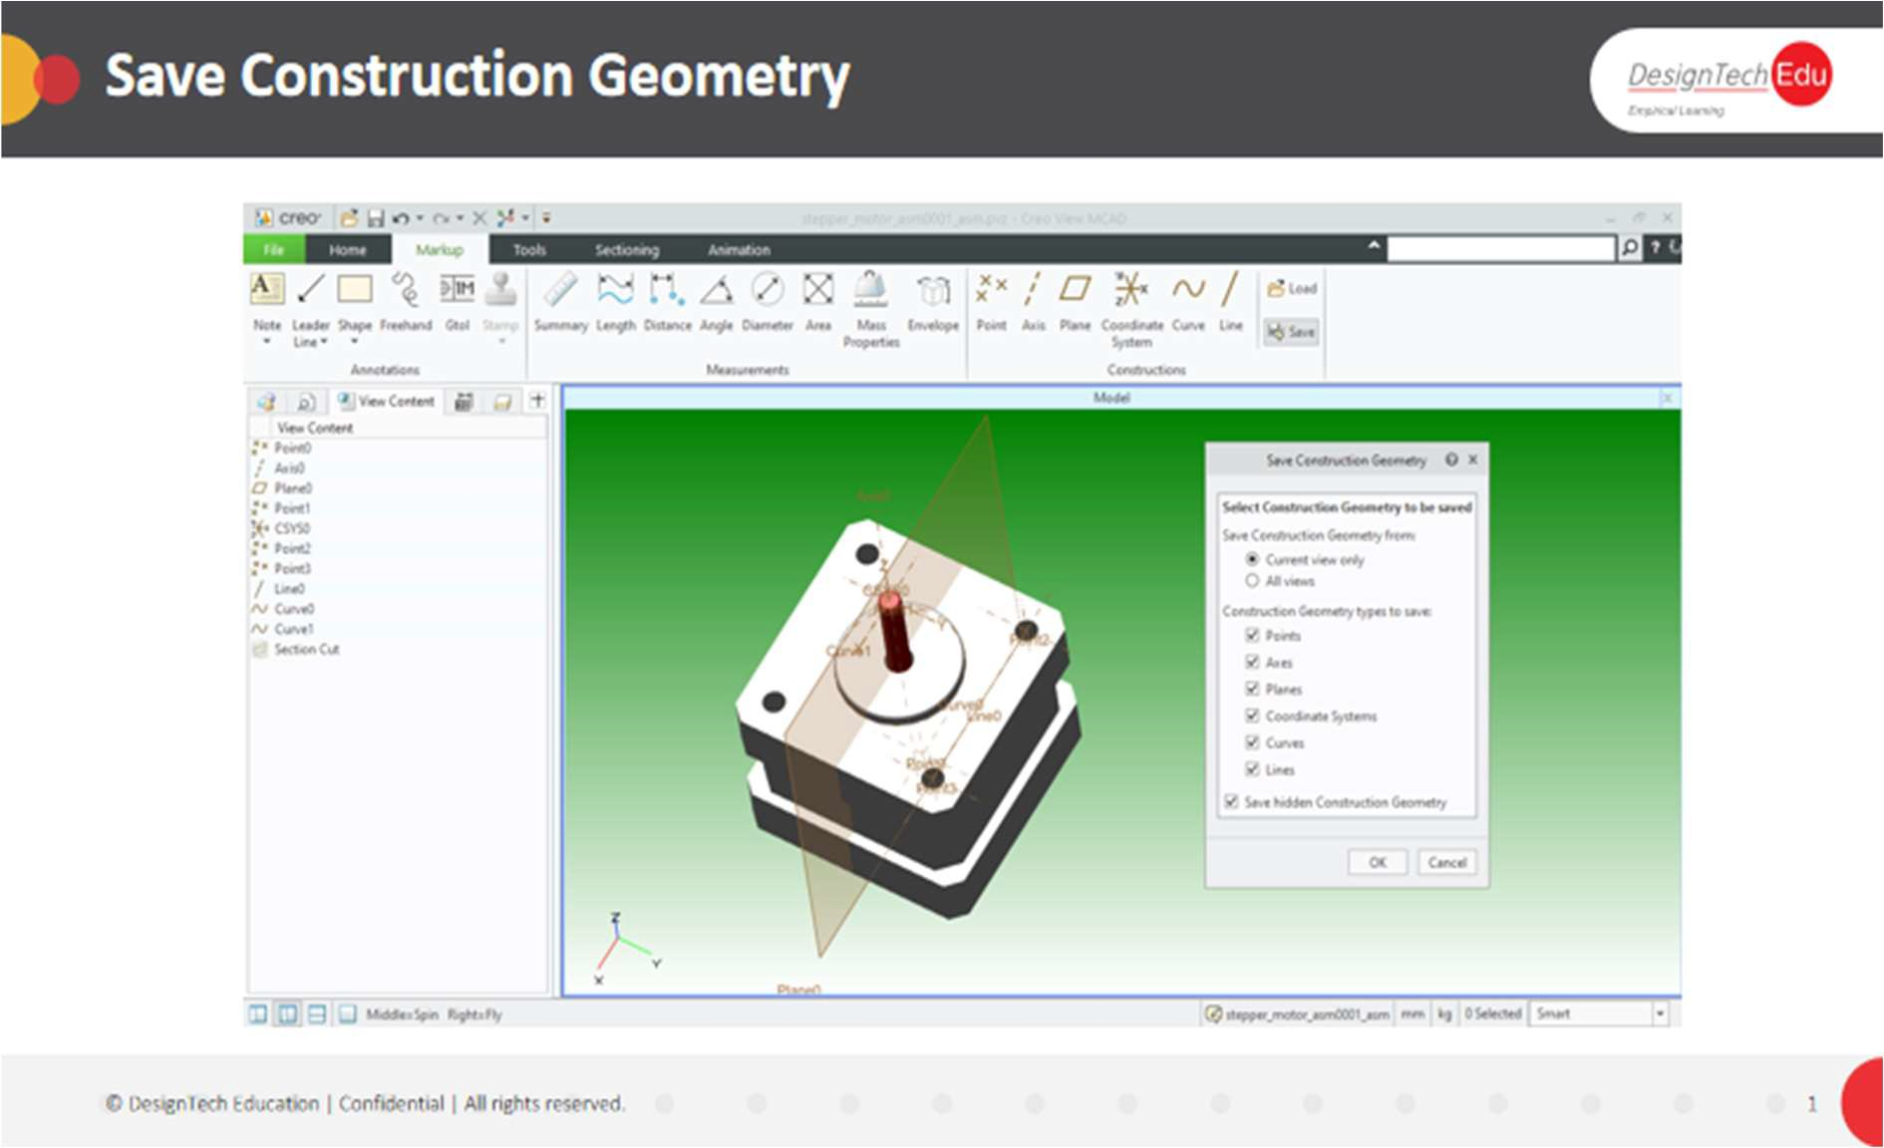

1. Click **Markup** >  **Save**. The **Save Construction Geometry** dialog box opens.
2. To select the construction geometry to save, select these options:
   * **Current view only** or **all views**
   * one or more options under **Construction Geometry types to save**
3. To save only visible construction geometry, clear the **Save hidden Construction Geometry** check box. To save all construction geometry, select the check box.
4. Click **OK**.

**Construction Geometry References**

Use the following references to create construction geometry:

|  |  |
| --- | --- |
| **Type** | **Reference** |
| **Point** | Vertex  Edge, curve, line, or axis Plane  Coordinate system |
| **Axis** | Two points Vertex  Construction geometry point Edge, curve, line, or axis Circular edge or curve Surface  Plane |

|  |  |
| --- | --- |
| Primary axis of  geometry | An edge or a curve of an object |
| Normal vector | Normal vector of the surface at the point you select on the object |
| **Plane** | Construction geometry point Vertex  Coordinate system Edge, curve, line, or axis Surface |
| **Coordinate System** | Point  Cylindrical surface Coordinate system |
| **Curve** | Point Surface |
| **Line** | Point  Curve or edge Circular entity |

**CHAPTER 8 - AUGMENTED REALITY**

**About Creating an Augmented Reality Experience for a CAD Model**

You can quickly create an Augmented Reality (AR) experience for your design and visualize it through ThingWorx View. This will be published to a hosted Augmented Reality Design Share Server.

Publish the experiences of your design using your PTC user account. The Augmented Reality Design Share allows you to publish up to five (5) experience models. Publishing additional experience models deletes the oldest experience model. An experience model is automatically deleted from the Augmented Reality Design Share Server after six months of publishing.

There are no restrictions on viewing models published to the Personal Service. Anyone who has the link to the experience model can visualize the experiences published to a Personal Experience Service.

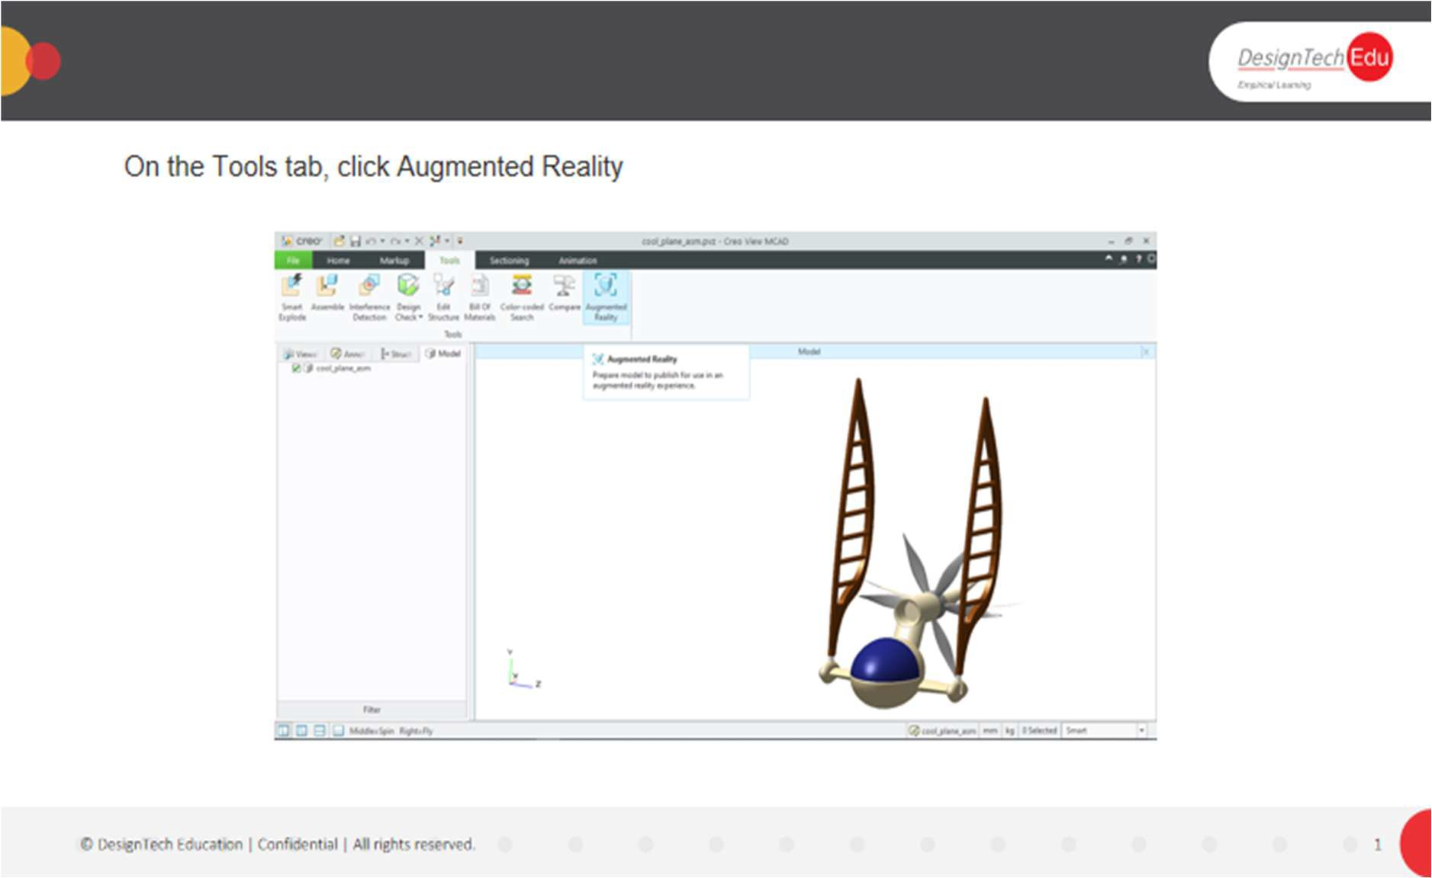

**Creating an Augmented Reality Experience for a CAD Model**

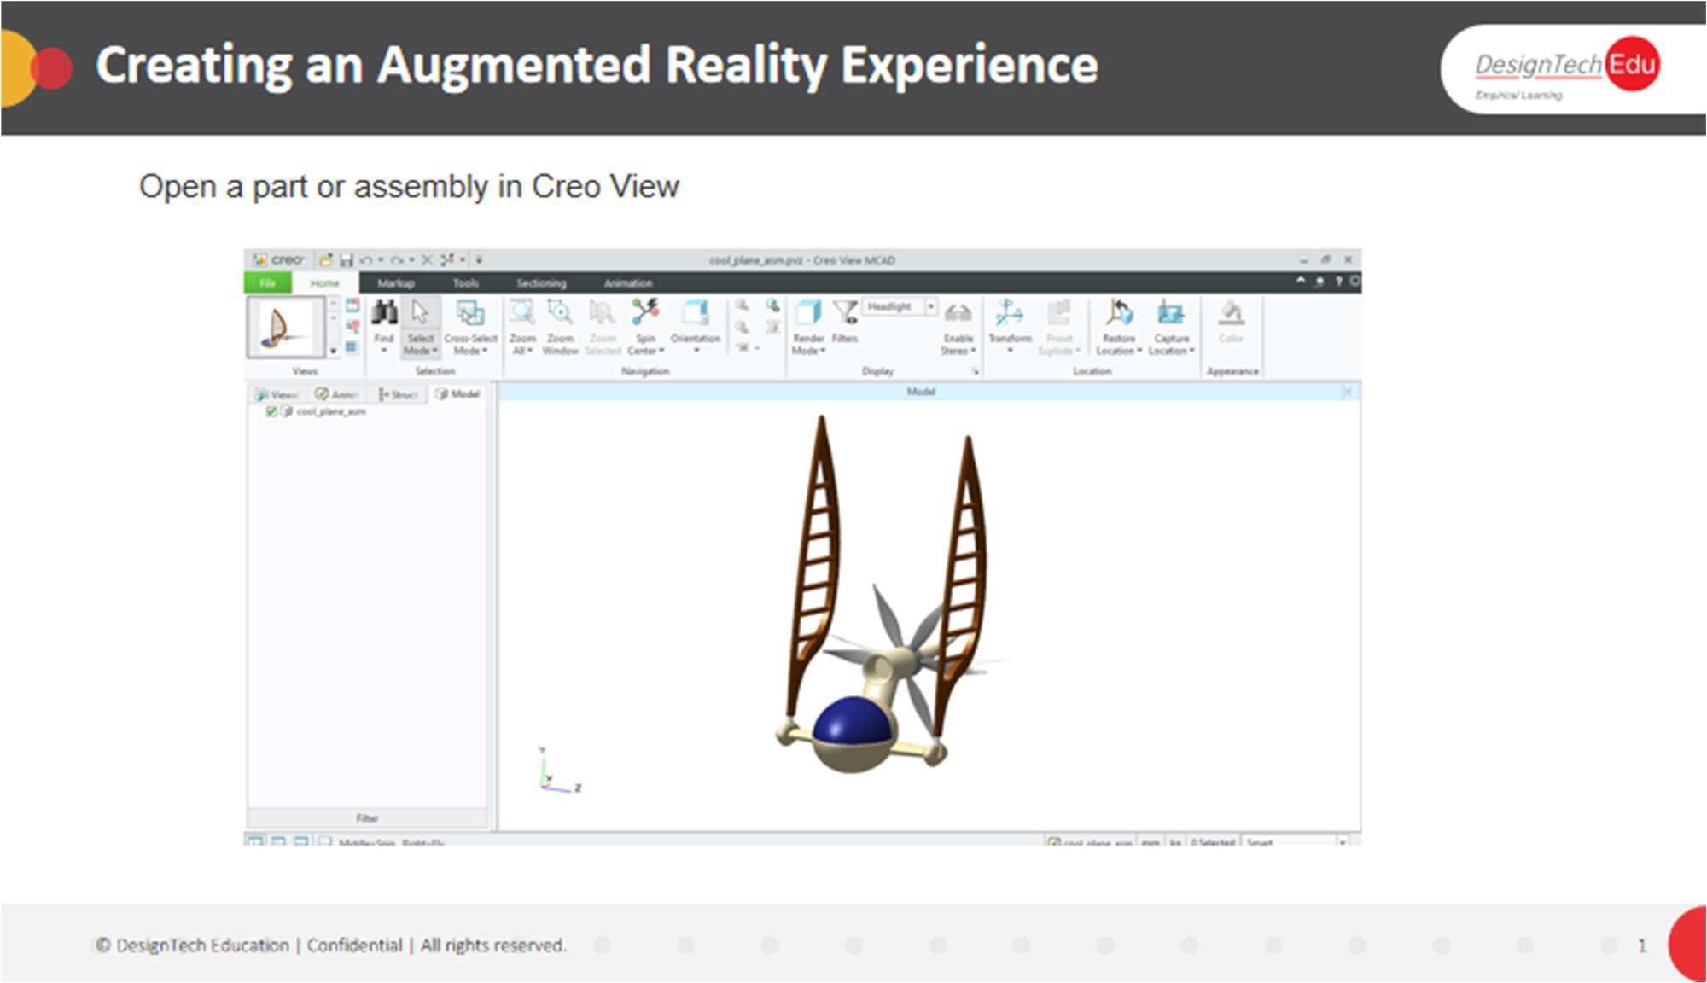

You must have a PTC user account to publish and share augmented reality experience models.

1. Open a part or assembly in Creo View.
2. On the Tools tab, click Augmented Reality. The Augmented Reality contextual ribbon opens.
3. Set a spatial target for your model.
4. Publish an Augmented Reality Experience Model.
5. Share your Augmented Reality Experience Model with others.
6. View the augmented reality experience.

An authentication dialog box opens the first time you publish, or share the experience model in the session. Use your PTC credentials to authenticate. The login is retained for a session.

**To Publish an Augmented Reality Experience Model**

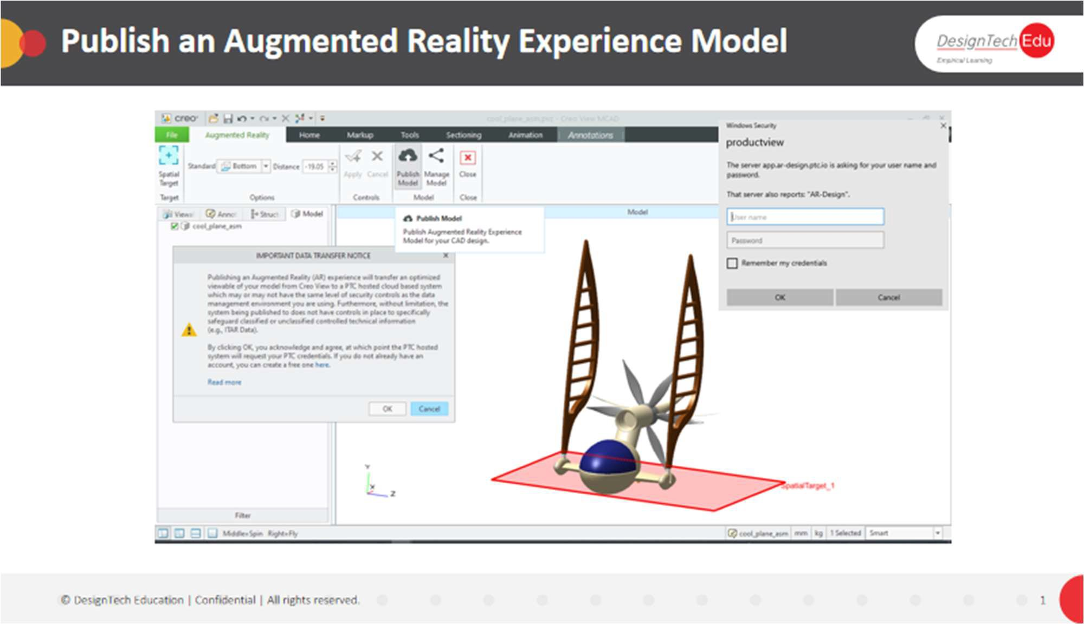

To publish an Augmented Reality Experience Model, you must have at least one spatial target defined.

1. In the Augmented Reality tab, click  Publish Model. The IMPORTANT DATA TRANSFER NOTICE warning message appears.
2. Read the message, IMPORTANT DATA TRANSFER NOTICE, then click OK to confirm that you acknowledge and agree to the content of the message. The Publish Experience Model dialog box opens.
3. Provide a unique name for the experience mode.
4. Select a value from the Viewable quality list to set the geometry publishing quality level.
5. For Publish to, select where to publish the Augmented Reality Experience model. The Publish to list contains a list of available Augmented Reality Design Share Services. It includes private services and additional Enterprise services.

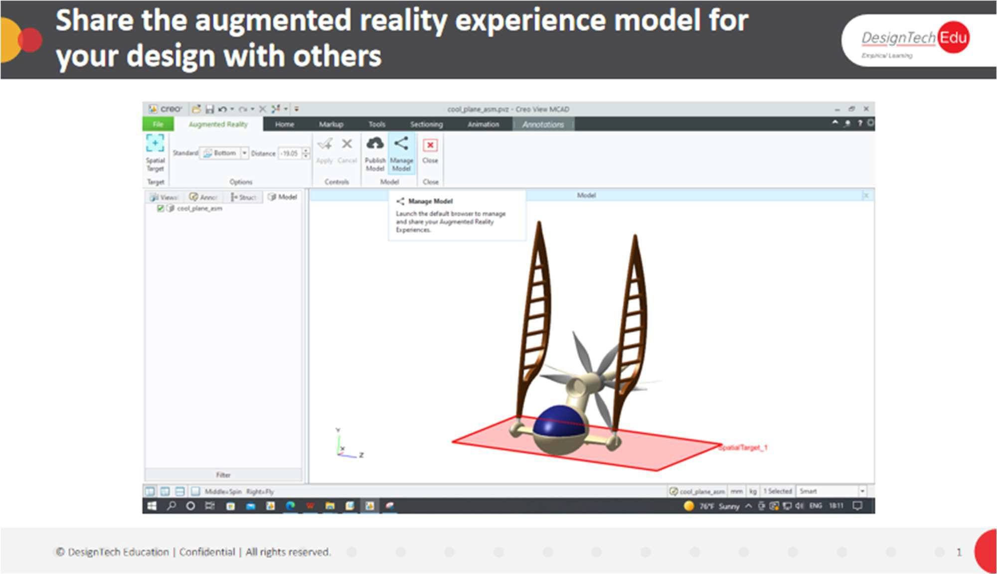

1. Select a spatial target from the Contents pane or the graphics window.

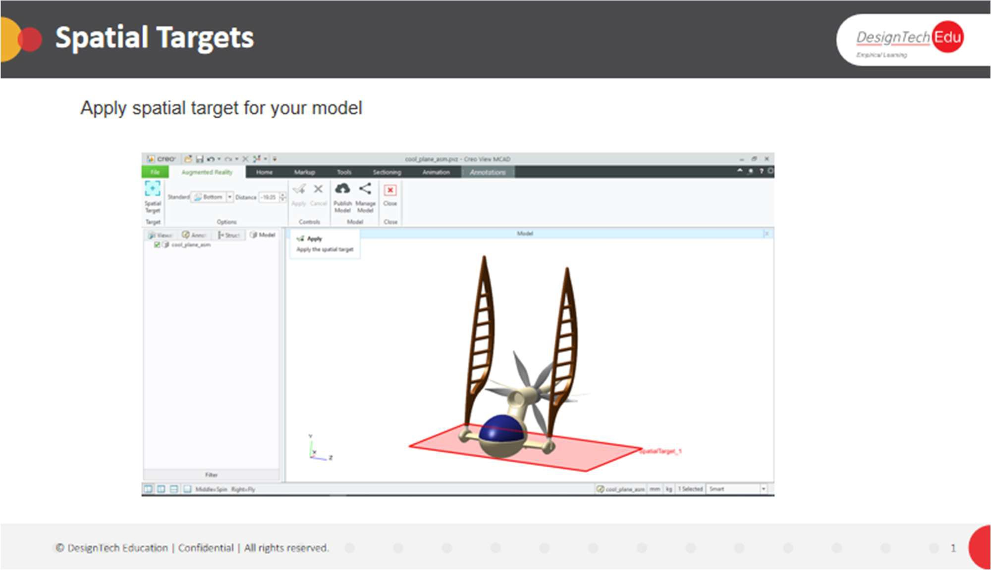

The spatial target box is automatically populated if there is only one spatial target defined.

1. Click OK. The experience model is published.